UNITED STATES
SECURITIES AND EXCHANGE COMMISSION
Washington, D.C. 20549
FORM 8-K
CURRENT REPORT
PURSUANT TO SECTION 13 OR 15(d)
OF THE SECURITIES EXCHANGE ACT OF 1934
Date of Report (Date of earliest event reported): May 14, 2025
OraSure Technologies, Inc.
(Exact Name of Registrant as Specified in Charter)
Delaware |  |  | 001-16537 |  |  | 36-4370966
(State or Other Jurisdiction  of Incorporation) |  |  | (Commission  File Number) |  |  | (I.R.S. Employer  Identification No.)
220 East First Street  Bethlehem, Pennsylvania |  |  | 18015-1360
(Address of Principal Executive Offices) |  |  | (Zip Code)
Registrant’s telephone number, including area code: 610-882-1820
N/A
(Former Name or Former Address, if changed since Last Report)
Securities registered pursuant to Section 12(b) of the Act:
Title of each class |  |  |  |  |  | Trading  Symbol(s) |  |  |  |  |  | Name of each exchange on which registered
Common Stock, $0.000001 par value per share |  |  |  |  |  | OSUR |  |  |  |  |  | The NASDAQ Stock Market LLC
Check the appropriate box below if the Form 8-K filing is intended to simultaneously satisfy the filing obligation of the Registrant under any of the following provisions:
o Written communications pursuant to Rule 425 under the Securities Act (17 CFR 230.425)
o Soliciting material pursuant to Rule 14a-12 under the Exchange Act (17 CFR 240.14a-12)
o Pre-commencement communications pursuant to Rule 14d-2(b) under the Exchange Act (17 CFR 240.14d-2(b))
o Pre-commencement communications pursuant to Rule 13e-4(c) under the Exchange Act (17 CFR 240.13e-4(c))
Indicate by a check mark whether the Registrant is an emerging growth company as defined in Rule 405 of the Securities Act of 1933 (§230.405 of this chapter) or Rule 12b-2 of the Securities Exchange Act of 1934 (§240.12b-2 of this chapter).
Emerging growth company o
If an emerging growth company, indicate by check mark if the Registrant has elected not to use the extended transition period for complying with any new or revised financial accounting standards provided pursuant to Section 13(a) of the Exchange Act. o
Item 5.02 Departure of Directors or Certain Officers; Election of Directors; Appointment of Certain Officers; Compensatory Arrangements of Certain Officers.

On May 14, 2025, at the 2025 Annual Meeting of Stockholders (the “Annual Meeting”) of OraSure Technologies, Inc. (the “Company”), the stockholders of the Company approved an amendment and restatement of the OraSure Technologies, Inc. 2000 Stock Award Plan (the “Stock Award Plan”) to increase the number of shares of common stock authorized for grant thereunder by 6,000,000 shares.

A detailed summary of the material features of the Stock Award Plan is set forth in the Company’s definitive proxy statement for the Annual Meeting filed with the U.S. Securities and Exchange Commission on April 4, 2025 (the “Proxy Statement”) under the caption “ Proposals Requiring Your Vote - Proposal No. 4. Amendment and Restatement of Stock Award Plan,” which description is incorporated herein by reference.

The descriptions of the Stock Award Plan contained herein and in the Proxy Statement do not purport to be complete and are qualified in their entirety by reference to the full text of the Stock Award Plan, which is attached hereto as Exhibit 10.1 to this Current Report on Form 8-K and is incorporated herein by reference.

Item 5.07 Submission of Matters to a Vote of Security Holders.

On May 14, 2025, the Company held its Annual Meeting virtually. As of March 21, 2025, the record date for the Annual Meeting, there were 77,488,414 outstanding shares of the Company’s common stock. The following is a summary of the items considered by stockholders and the corresponding voting results at the Annual Meeting:

ITEM 1. Election of Three Class I Directors for Terms Ending in 2028.

NAME |  |  | Votes For |  |  | Votes Against |  |  | Abstentions |  |  | Broker Non-Votes
Carrie Eglinton Manner |  |  | 55,911,240 |  |  | 2,507,538 |  |  | 259,542 |  |  | 7,988,307
John P. Kenny |  |  | 55,713,411 |  |  | 2,722,162 |  |  | 242,747 |  |  | 7,988,307
David J. Shulkin, M.D. |  |  | 54,577,181 |  |  | 3,858,592 |  |  | 242,547 |  |  | 7,988,307

ITEM 2. Ratification of the Appointment of Grant Thornton LLP as the Company’s Independent Registered Public Accounting Firm for Fiscal Year 2025.

Votes For |  |  | Votes Against |  |  | Abstentions
64,990,952 |  |  | 1,151,283 |  |  | 524,392

ITEM 3. Advisory (Non-Binding) Vote to Approve the Resolution on the Company’s Executive Compensation.

Votes For |  |  | Votes Against |  |  | Abstentions |  |  | Broker Non-Votes
51,997,355 |  |  | 6,477,192 |  |  | 203,773 |  |  | 7,988,307

ITEM 4. Approval of an Amendment and Restatement of the Stock Award Plan to Increase the Shares Authorized For Issuance Thereunder.

Votes For |  |  | Votes Against |  |  | Abstentions |  |  | Broker Non-Votes
51,456,219 |  |  | 6,966,928 |  |  | 255,173 |  |  | 7,988,307

Item 9.01 Financial Statements and Exhibits

(d) Exhibits

The following exhibits are being filed herewith:

Exhibit Number |  |  |  |  |  | Description
10.1 |  |  |  |  |  | Amended and Restated OraSure Technologies, Inc. 2000 Stock Award Plan.
104 |  |  |  |  |  | Cover Page Interactive Data File (embedded within the Inline XBRL document)

SIGNATURE
Pursuant to the requirements of the Securities Exchange Act of 1934, as amended, the registrant has duly caused this report to be signed on its behalf by the undersigned hereunto duly authorized.
 |  |  | ORASURE TECHNOLOGIES, INC.
Date: May 14, 2025 |  |  | By: |  |  | /s/ Carrie Eglinton Manner
 |  |  |  |  |  | Carrie Eglinton Manner
 |  |  |  |  |  | President and Chief Executive Officer
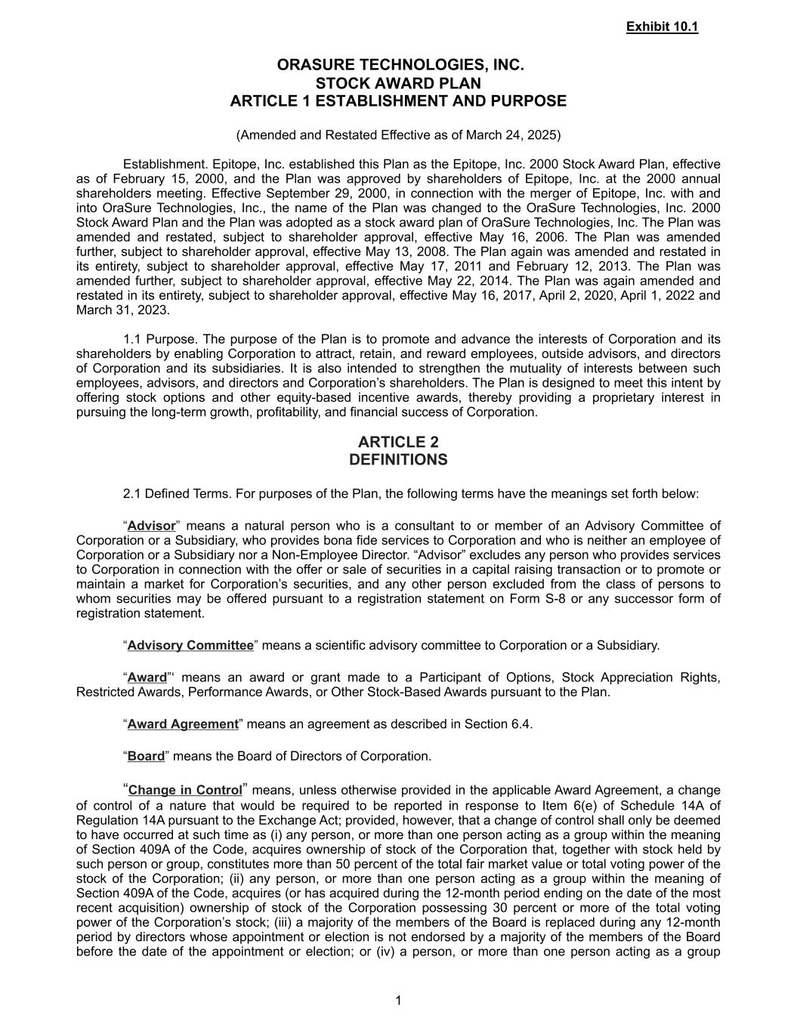

ORASURE TECHNOLOGIES, INC. STOCK AWARD PLAN ARTICLE 1 ESTABLISHMENT AND PURPOSE (Amended and Restated Effective as of March 24, 2025) Establishment. Epitope, Inc. established this Plan as the Epitope, Inc. 2000 Stock Award Plan, effective as of February 15, 2000, and the Plan was approved by shareholders of Epitope, Inc. at the 2000 annual shareholders meeting. Effective September 29, 2000, in connection with the merger of Epitope, Inc. with and into OraSure Technologies, Inc., the name of the Plan was changed to the OraSure Technologies, Inc. 2000 Stock Award Plan and the Plan was adopted as a stock award plan of OraSure Technologies, Inc. The Plan was amended and restated, subject to shareholder approval, effective May 16, 2006. The Plan was amended further, subject to shareholder approval, effective May 13, 2008. The Plan again was amended and restated in its entirety, subject to shareholder approval, effective May 17, 2011 and February 12, 2013. The Plan was amended further, subject to shareholder approval, effective May 22, 2014. The Plan was again amended and restated in its entirety, subject to shareholder approval, effective May 16, 2017, April 2, 2020, April 1, 2022 and March 31, 2023. 1.1 Purpose. The purpose of the Plan is to promote and advance the interests of Corporation and its shareholders by enabling Corporation to attract, retain, and reward employees, outside advisors, and directors of Corporation and its subsidiaries. It is also intended to strengthen the mutuality of interests between such employees, advisors, and directors and Corporation’s shareholders. The Plan is designed to meet this intent by offering stock options and other equity-based incentive awards, thereby providing a proprietary interest in pursuing the long-term growth, profitability, and financial success of Corporation. ARTICLE 2 DEFINITIONS 2.1 Defined Terms. For purposes of the Plan, the following terms have the meanings set forth below: “Advisor” means a natural person who is a consultant to or member of an Advisory Committee of Corporation or a Subsidiary, who provides bona fide services to Corporation and who is neither an employee of Corporation or a Subsidiary nor a Non-Employee Director. “Advisor” excludes any person who provides services to Corporation in connection with the offer or sale of securities in a capital raising transaction or to promote or maintain a market for Corporation’s securities, and any other person excluded from the class of persons to whom securities may be offered pursuant to a registration statement on Form S-8 or any successor form of registration statement. “Advisory Committee” means a scientific advisory committee to Corporation or a Subsidiary. “Award”‘ means an award or grant made to a Participant of Options, Stock Appreciation Rights, Restricted Awards, Performance Awards, or Other Stock-Based Awards pursuant to the Plan. “Award Agreement” means an agreement as described in Section 6.4. “Board” means the Board of Directors of Corporation. “Change in Control” means, unless otherwise provided in the applicable Award Agreement, a change of control of a nature that would be required to be reported in response to Item 6(e) of Schedule 14A of Regulation 14A pursuant to the Exchange Act; provided, however, that a change of control shall only be deemed to have occurred at such time as (i) any person, or more than one person acting as a group within the meaning of Section 409A of the Code, acquires ownership of stock of the Corporation that, together with stock held by such person or group, constitutes more than 50 percent of the total fair market value or total voting power of the stock of the Corporation; (ii) any person, or more than one person acting as a group within the meaning of Section 409A of the Code, acquires (or has acquired during the 12-month period ending on the date of the most recent acquisition) ownership of stock of the Corporation possessing 30 percent or more of the total voting power of the Corporation’s stock; (iii) a majority of the members of the Board is replaced during any 12-month period by directors whose appointment or election is not endorsed by a majority of the members of the Board before the date of the appointment or election; or (iv) a person, or more than one person acting as a group 1 Exhibit 10.1

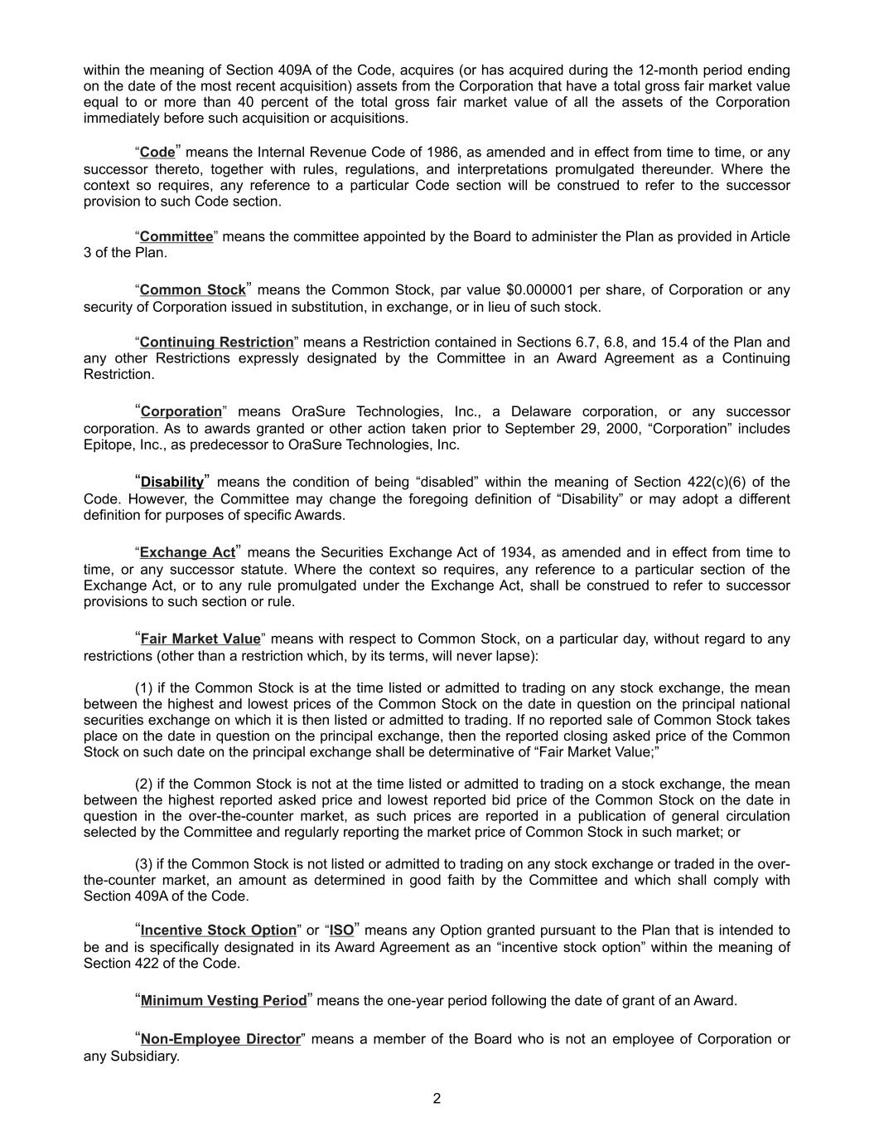
within the meaning of Section 409A of the Code, acquires (or has acquired during the 12-month period ending on the date of the most recent acquisition) assets from the Corporation that have a total gross fair market value equal to or more than 40 percent of the total gross fair market value of all the assets of the Corporation immediately before such acquisition or acquisitions. “Code” means the Internal Revenue Code of 1986, as amended and in effect from time to time, or any successor thereto, together with rules, regulations, and interpretations promulgated thereunder. Where the context so requires, any reference to a particular Code section will be construed to refer to the successor provision to such Code section. “Committee” means the committee appointed by the Board to administer the Plan as provided in Article 3 of the Plan. “Common Stock” means the Common Stock, par value $0.000001 per share, of Corporation or any security of Corporation issued in substitution, in exchange, or in lieu of such stock. “Continuing Restriction” means a Restriction contained in Sections 6.7, 6.8, and 15.4 of the Plan and any other Restrictions expressly designated by the Committee in an Award Agreement as a Continuing Restriction. “Corporation” means OraSure Technologies, Inc., a Delaware corporation, or any successor corporation. As to awards granted or other action taken prior to September 29, 2000, “Corporation” includes Epitope, Inc., as predecessor to OraSure Technologies, Inc. “Disability” means the condition of being “disabled” within the meaning of Section 422(c)(6) of the Code. However, the Committee may change the foregoing definition of “Disability” or may adopt a different definition for purposes of specific Awards. “Exchange Act” means the Securities Exchange Act of 1934, as amended and in effect from time to time, or any successor statute. Where the context so requires, any reference to a particular section of the Exchange Act, or to any rule promulgated under the Exchange Act, shall be construed to refer to successor provisions to such section or rule. “Fair Market Value” means with respect to Common Stock, on a particular day, without regard to any restrictions (other than a restriction which, by its terms, will never lapse): (1) if the Common Stock is at the time listed or admitted to trading on any stock exchange, the mean between the highest and lowest prices of the Common Stock on the date in question on the principal national securities exchange on which it is then listed or admitted to trading. If no reported sale of Common Stock takes place on the date in question on the principal exchange, then the reported closing asked price of the Common Stock on such date on the principal exchange shall be determinative of “Fair Market Value;” (2) if the Common Stock is not at the time listed or admitted to trading on a stock exchange, the mean between the highest reported asked price and lowest reported bid price of the Common Stock on the date in question in the over-the-counter market, as such prices are reported in a publication of general circulation selected by the Committee and regularly reporting the market price of Common Stock in such market; or (3) if the Common Stock is not listed or admitted to trading on any stock exchange or traded in the over- the-counter market, an amount as determined in good faith by the Committee and which shall comply with Section 409A of the Code. “Incentive Stock Option” or “ISO” means any Option granted pursuant to the Plan that is intended to be and is specifically designated in its Award Agreement as an “incentive stock option” within the meaning of Section 422 of the Code. “Minimum Vesting Period” means the one-year period following the date of grant of an Award. “Non-Employee Director” means a member of the Board who is not an employee of Corporation or any Subsidiary. 2

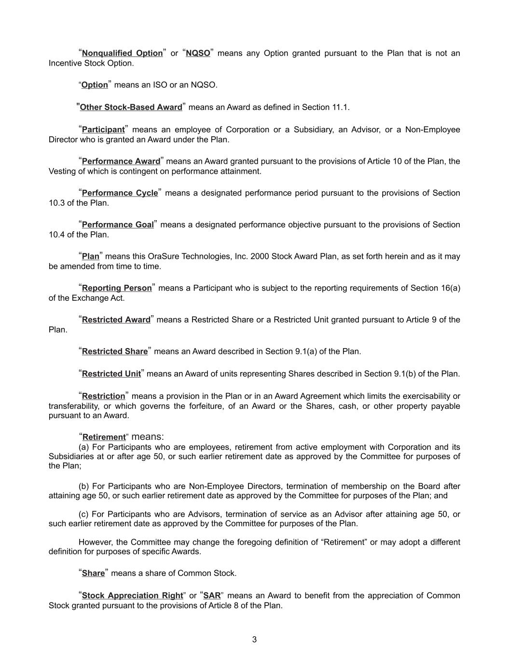
“Nonqualified Option” or “NQSO” means any Option granted pursuant to the Plan that is not an Incentive Stock Option. “Option” means an ISO or an NQSO. "Other Stock-Based Award” means an Award as defined in Section 11.1. “Participant” means an employee of Corporation or a Subsidiary, an Advisor, or a Non-Employee Director who is granted an Award under the Plan. “Performance Award” means an Award granted pursuant to the provisions of Article 10 of the Plan, the Vesting of which is contingent on performance attainment. “Performance Cycle” means a designated performance period pursuant to the provisions of Section 10.3 of the Plan. “Performance Goal” means a designated performance objective pursuant to the provisions of Section 10.4 of the Plan. “Plan” means this OraSure Technologies, Inc. 2000 Stock Award Plan, as set forth herein and as it may be amended from time to time. “Reporting Person” means a Participant who is subject to the reporting requirements of Section 16(a) of the Exchange Act. “Restricted Award” means a Restricted Share or a Restricted Unit granted pursuant to Article 9 of the Plan. “Restricted Share” means an Award described in Section 9.1(a) of the Plan. “Restricted Unit” means an Award of units representing Shares described in Section 9.1(b) of the Plan. “Restriction” means a provision in the Plan or in an Award Agreement which limits the exercisability or transferability, or which governs the forfeiture, of an Award or the Shares, cash, or other property payable pursuant to an Award. “Retirement” means: (a) For Participants who are employees, retirement from active employment with Corporation and its Subsidiaries at or after age 50, or such earlier retirement date as approved by the Committee for purposes of the Plan; (b) For Participants who are Non-Employee Directors, termination of membership on the Board after attaining age 50, or such earlier retirement date as approved by the Committee for purposes of the Plan; and (c) For Participants who are Advisors, termination of service as an Advisor after attaining age 50, or such earlier retirement date as approved by the Committee for purposes of the Plan. However, the Committee may change the foregoing definition of “Retirement” or may adopt a different definition for purposes of specific Awards. “Share” means a share of Common Stock. “Stock Appreciation Right” or “SAR” means an Award to benefit from the appreciation of Common Stock granted pursuant to the provisions of Article 8 of the Plan. 3

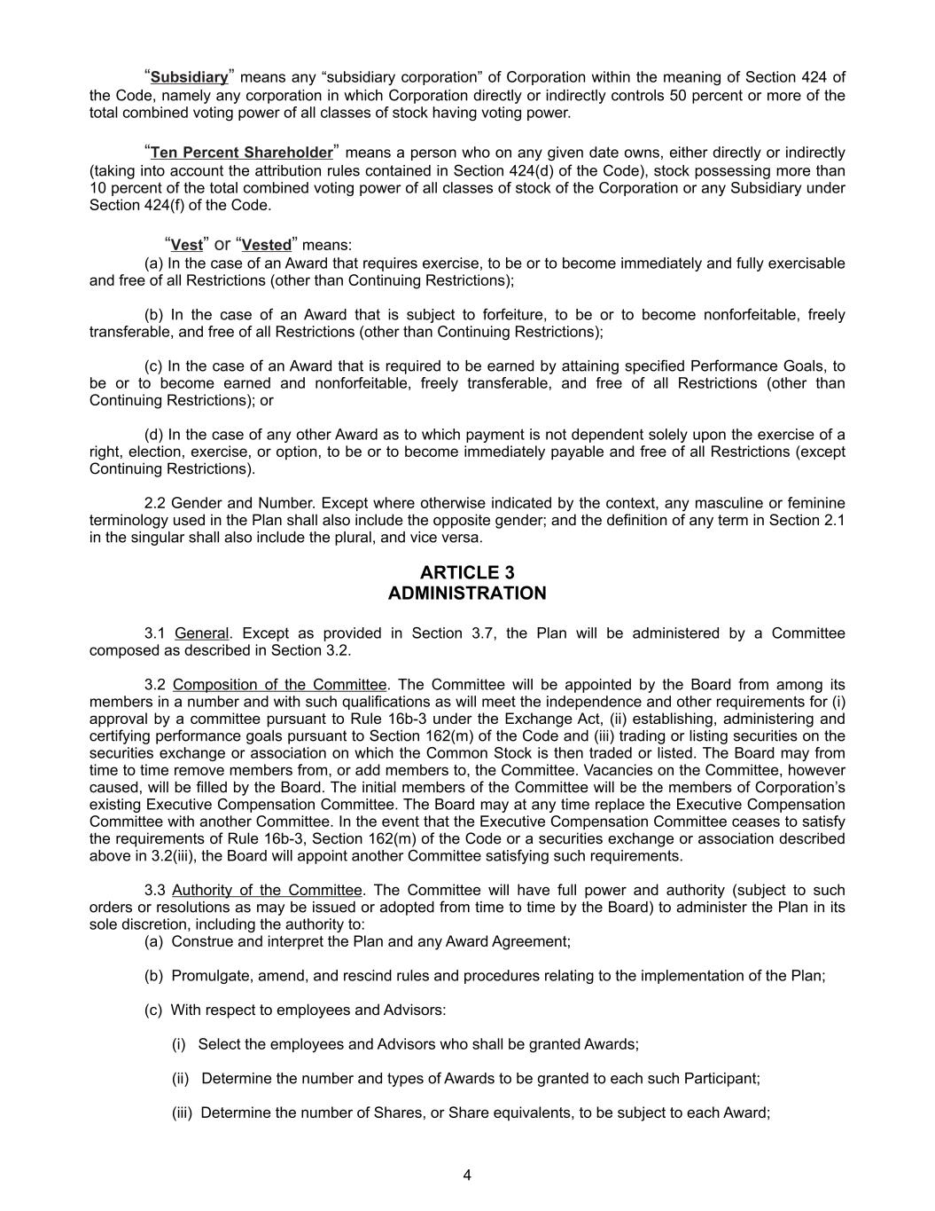
“Subsidiary” means any “subsidiary corporation” of Corporation within the meaning of Section 424 of the Code, namely any corporation in which Corporation directly or indirectly controls 50 percent or more of the total combined voting power of all classes of stock having voting power. “Ten Percent Shareholder” means a person who on any given date owns, either directly or indirectly (taking into account the attribution rules contained in Section 424(d) of the Code), stock possessing more than 10 percent of the total combined voting power of all classes of stock of the Corporation or any Subsidiary under Section 424(f) of the Code. “Vest” or “Vested” means: (a) In the case of an Award that requires exercise, to be or to become immediately and fully exercisable and free of all Restrictions (other than Continuing Restrictions); (b) In the case of an Award that is subject to forfeiture, to be or to become nonforfeitable, freely transferable, and free of all Restrictions (other than Continuing Restrictions); (c) In the case of an Award that is required to be earned by attaining specified Performance Goals, to be or to become earned and nonforfeitable, freely transferable, and free of all Restrictions (other than Continuing Restrictions); or (d) In the case of any other Award as to which payment is not dependent solely upon the exercise of a right, election, exercise, or option, to be or to become immediately payable and free of all Restrictions (except Continuing Restrictions). 2.2 Gender and Number. Except where otherwise indicated by the context, any masculine or feminine terminology used in the Plan shall also include the opposite gender; and the definition of any term in Section 2.1 in the singular shall also include the plural, and vice versa. ARTICLE 3 ADMINISTRATION 3.1 General. Except as provided in Section 3.7, the Plan will be administered by a Committee composed as described in Section 3.2. 3.2 Composition of the Committee. The Committee will be appointed by the Board from among its members in a number and with such qualifications as will meet the independence and other requirements for (i) approval by a committee pursuant to Rule 16b-3 under the Exchange Act, (ii) establishing, administering and certifying performance goals pursuant to Section 162(m) of the Code and (iii) trading or listing securities on the securities exchange or association on which the Common Stock is then traded or listed. The Board may from time to time remove members from, or add members to, the Committee. Vacancies on the Committee, however caused, will be filled by the Board. The initial members of the Committee will be the members of Corporation’s existing Executive Compensation Committee. The Board may at any time replace the Executive Compensation Committee with another Committee. In the event that the Executive Compensation Committee ceases to satisfy the requirements of Rule 16b-3, Section 162(m) of the Code or a securities exchange or association described above in 3.2(iii), the Board will appoint another Committee satisfying such requirements. 3.3 Authority of the Committee. The Committee will have full power and authority (subject to such orders or resolutions as may be issued or adopted from time to time by the Board) to administer the Plan in its sole discretion, including the authority to: (a) Construe and interpret the Plan and any Award Agreement; (b) Promulgate, amend, and rescind rules and procedures relating to the implementation of the Plan; (c) With respect to employees and Advisors: (i) Select the employees and Advisors who shall be granted Awards; (ii) Determine the number and types of Awards to be granted to each such Participant; (iii) Determine the number of Shares, or Share equivalents, to be subject to each Award; 4

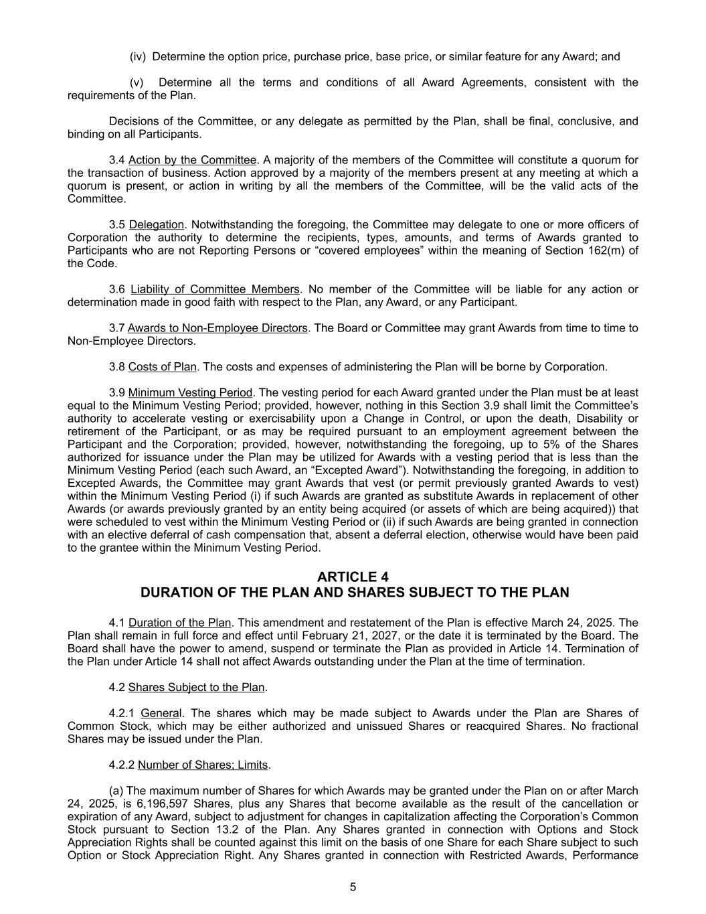
(iv) Determine the option price, purchase price, base price, or similar feature for any Award; and (v) Determine all the terms and conditions of all Award Agreements, consistent with the requirements of the Plan. Decisions of the Committee, or any delegate as permitted by the Plan, shall be final, conclusive, and binding on all Participants. 3.4 Action by the Committee. A majority of the members of the Committee will constitute a quorum for the transaction of business. Action approved by a majority of the members present at any meeting at which a quorum is present, or action in writing by all the members of the Committee, will be the valid acts of the Committee. 3.5 Delegation. Notwithstanding the foregoing, the Committee may delegate to one or more officers of Corporation the authority to determine the recipients, types, amounts, and terms of Awards granted to Participants who are not Reporting Persons or “covered employees” within the meaning of Section 162(m) of the Code. 3.6 Liability of Committee Members. No member of the Committee will be liable for any action or determination made in good faith with respect to the Plan, any Award, or any Participant. 3.7 Awards to Non-Employee Directors. The Board or Committee may grant Awards from time to time to Non-Employee Directors. 3.8 Costs of Plan. The costs and expenses of administering the Plan will be borne by Corporation. 3.9 Minimum Vesting Period. The vesting period for each Award granted under the Plan must be at least equal to the Minimum Vesting Period; provided, however, nothing in this Section 3.9 shall limit the Committee’s authority to accelerate vesting or exercisability upon a Change in Control, or upon the death, Disability or retirement of the Participant, or as may be required pursuant to an employment agreement between the Participant and the Corporation; provided, however, notwithstanding the foregoing, up to 5% of the Shares authorized for issuance under the Plan may be utilized for Awards with a vesting period that is less than the Minimum Vesting Period (each such Award, an “Excepted Award”). Notwithstanding the foregoing, in addition to Excepted Awards, the Committee may grant Awards that vest (or permit previously granted Awards to vest) within the Minimum Vesting Period (i) if such Awards are granted as substitute Awards in replacement of other Awards (or awards previously granted by an entity being acquired (or assets of which are being acquired)) that were scheduled to vest within the Minimum Vesting Period or (ii) if such Awards are being granted in connection with an elective deferral of cash compensation that, absent a deferral election, otherwise would have been paid to the grantee within the Minimum Vesting Period. ARTICLE 4 DURATION OF THE PLAN AND SHARES SUBJECT TO THE PLAN 4.1 Duration of the Plan. This amendment and restatement of the Plan is effective March 24, 2025. The Plan shall remain in full force and effect until February 21, 2027, or the date it is terminated by the Board. The Board shall have the power to amend, suspend or terminate the Plan as provided in Article 14. Termination of the Plan under Article 14 shall not affect Awards outstanding under the Plan at the time of termination. 4.2 Shares Subject to the Plan. 4.2.1 General. The shares which may be made subject to Awards under the Plan are Shares of Common Stock, which may be either authorized and unissued Shares or reacquired Shares. No fractional Shares may be issued under the Plan. 4.2.2 Number of Shares; Limits. (a) The maximum number of Shares for which Awards may be granted under the Plan on or after March 24, 2025, is 6,196,597 Shares, plus any Shares that become available as the result of the cancellation or expiration of any Award, subject to adjustment for changes in capitalization affecting the Corporation’s Common Stock pursuant to Section 13.2 of the Plan. Any Shares granted in connection with Options and Stock Appreciation Rights shall be counted against this limit on the basis of one Share for each Share subject to such Option or Stock Appreciation Right. Any Shares granted in connection with Restricted Awards, Performance 5

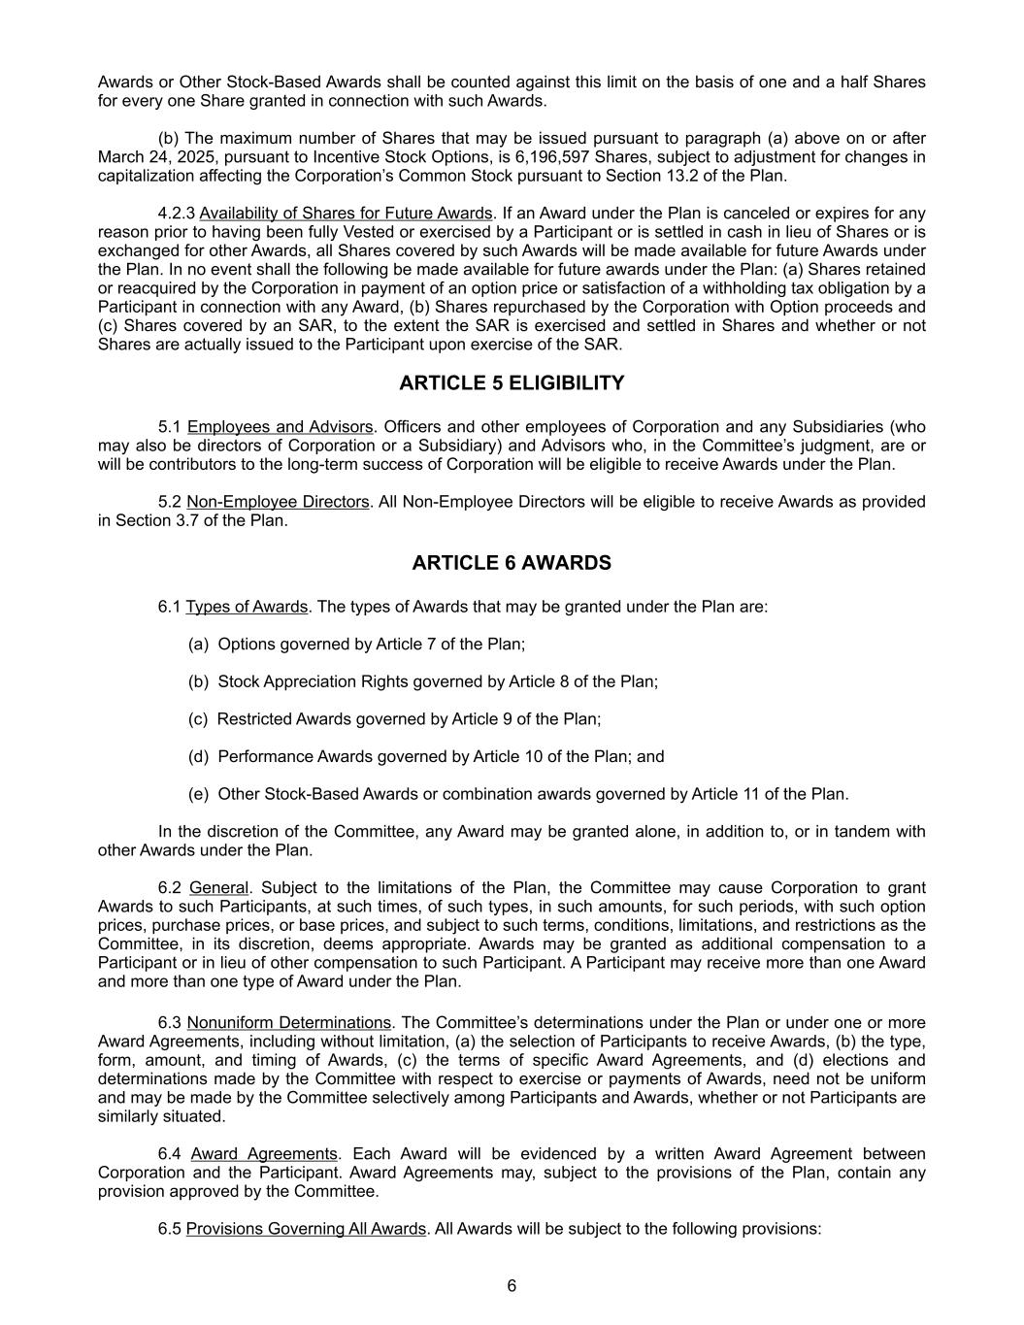
Awards or Other Stock-Based Awards shall be counted against this limit on the basis of one and a half Shares for every one Share granted in connection with such Awards. (b) The maximum number of Shares that may be issued pursuant to paragraph (a) above on or after March 24, 2025, pursuant to Incentive Stock Options, is 6,196,597 Shares, subject to adjustment for changes in capitalization affecting the Corporation’s Common Stock pursuant to Section 13.2 of the Plan. 4.2.3 Availability of Shares for Future Awards. If an Award under the Plan is canceled or expires for any reason prior to having been fully Vested or exercised by a Participant or is settled in cash in lieu of Shares or is exchanged for other Awards, all Shares covered by such Awards will be made available for future Awards under the Plan. In no event shall the following be made available for future awards under the Plan: (a) Shares retained or reacquired by the Corporation in payment of an option price or satisfaction of a withholding tax obligation by a Participant in connection with any Award, (b) Shares repurchased by the Corporation with Option proceeds and (c) Shares covered by an SAR, to the extent the SAR is exercised and settled in Shares and whether or not Shares are actually issued to the Participant upon exercise of the SAR. ARTICLE 5 ELIGIBILITY 5.1 Employees and Advisors. Officers and other employees of Corporation and any Subsidiaries (who may also be directors of Corporation or a Subsidiary) and Advisors who, in the Committee’s judgment, are or will be contributors to the long-term success of Corporation will be eligible to receive Awards under the Plan. 5.2 Non-Employee Directors. All Non-Employee Directors will be eligible to receive Awards as provided in Section 3.7 of the Plan. ARTICLE 6 AWARDS 6.1 Types of Awards. The types of Awards that may be granted under the Plan are: (a) Options governed by Article 7 of the Plan; (b) Stock Appreciation Rights governed by Article 8 of the Plan; (c) Restricted Awards governed by Article 9 of the Plan; (d) Performance Awards governed by Article 10 of the Plan; and (e) Other Stock-Based Awards or combination awards governed by Article 11 of the Plan. In the discretion of the Committee, any Award may be granted alone, in addition to, or in tandem with other Awards under the Plan. 6.2 General. Subject to the limitations of the Plan, the Committee may cause Corporation to grant Awards to such Participants, at such times, of such types, in such amounts, for such periods, with such option prices, purchase prices, or base prices, and subject to such terms, conditions, limitations, and restrictions as the Committee, in its discretion, deems appropriate. Awards may be granted as additional compensation to a Participant or in lieu of other compensation to such Participant. A Participant may receive more than one Award and more than one type of Award under the Plan. 6.3 Nonuniform Determinations. The Committee’s determinations under the Plan or under one or more Award Agreements, including without limitation, (a) the selection of Participants to receive Awards, (b) the type, form, amount, and timing of Awards, (c) the terms of specific Award Agreements, and (d) elections and determinations made by the Committee with respect to exercise or payments of Awards, need not be uniform and may be made by the Committee selectively among Participants and Awards, whether or not Participants are similarly situated. 6.4 Award Agreements. Each Award will be evidenced by a written Award Agreement between Corporation and the Participant. Award Agreements may, subject to the provisions of the Plan, contain any provision approved by the Committee. 6.5 Provisions Governing All Awards. All Awards will be subject to the following provisions: 6

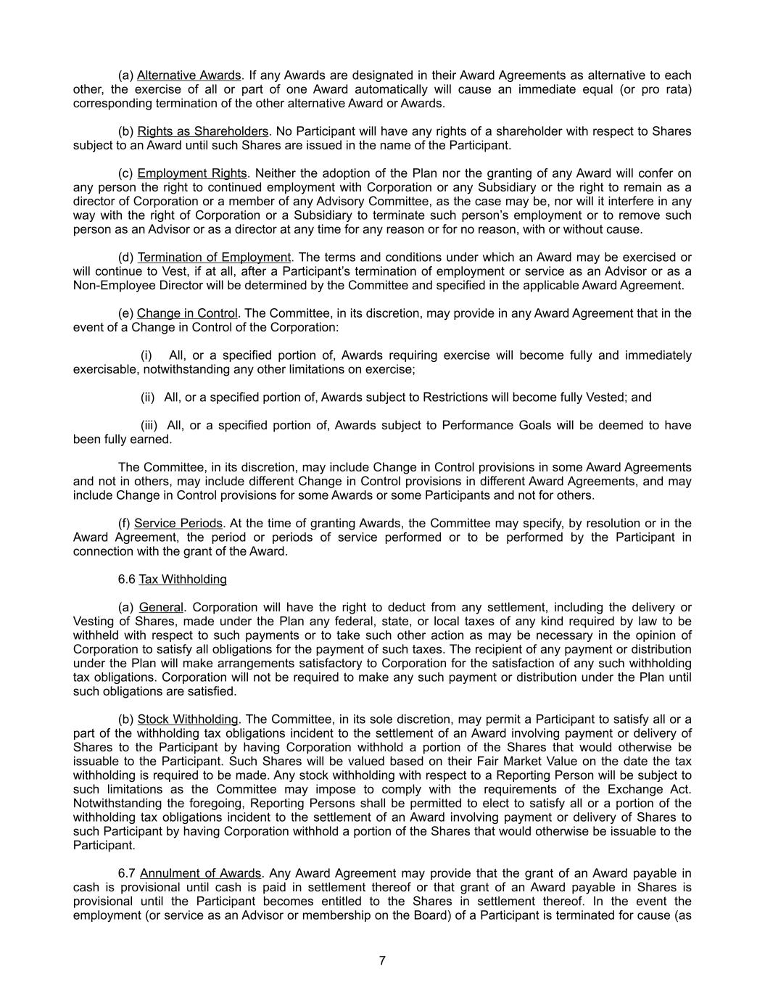
(a) Alternative Awards. If any Awards are designated in their Award Agreements as alternative to each other, the exercise of all or part of one Award automatically will cause an immediate equal (or pro rata) corresponding termination of the other alternative Award or Awards. (b) Rights as Shareholders. No Participant will have any rights of a shareholder with respect to Shares subject to an Award until such Shares are issued in the name of the Participant. (c) Employment Rights. Neither the adoption of the Plan nor the granting of any Award will confer on any person the right to continued employment with Corporation or any Subsidiary or the right to remain as a director of Corporation or a member of any Advisory Committee, as the case may be, nor will it interfere in any way with the right of Corporation or a Subsidiary to terminate such person’s employment or to remove such person as an Advisor or as a director at any time for any reason or for no reason, with or without cause. (d) Termination of Employment. The terms and conditions under which an Award may be exercised or will continue to Vest, if at all, after a Participant’s termination of employment or service as an Advisor or as a Non-Employee Director will be determined by the Committee and specified in the applicable Award Agreement. (e) Change in Control. The Committee, in its discretion, may provide in any Award Agreement that in the event of a Change in Control of the Corporation: (i) All, or a specified portion of, Awards requiring exercise will become fully and immediately exercisable, notwithstanding any other limitations on exercise; (ii) All, or a specified portion of, Awards subject to Restrictions will become fully Vested; and (iii) All, or a specified portion of, Awards subject to Performance Goals will be deemed to have been fully earned. The Committee, in its discretion, may include Change in Control provisions in some Award Agreements and not in others, may include different Change in Control provisions in different Award Agreements, and may include Change in Control provisions for some Awards or some Participants and not for others. (f) Service Periods. At the time of granting Awards, the Committee may specify, by resolution or in the Award Agreement, the period or periods of service performed or to be performed by the Participant in connection with the grant of the Award. 6.6 Tax Withholding (a) General. Corporation will have the right to deduct from any settlement, including the delivery or Vesting of Shares, made under the Plan any federal, state, or local taxes of any kind required by law to be withheld with respect to such payments or to take such other action as may be necessary in the opinion of Corporation to satisfy all obligations for the payment of such taxes. The recipient of any payment or distribution under the Plan will make arrangements satisfactory to Corporation for the satisfaction of any such withholding tax obligations. Corporation will not be required to make any such payment or distribution under the Plan until such obligations are satisfied. (b) Stock Withholding. The Committee, in its sole discretion, may permit a Participant to satisfy all or a part of the withholding tax obligations incident to the settlement of an Award involving payment or delivery of Shares to the Participant by having Corporation withhold a portion of the Shares that would otherwise be issuable to the Participant. Such Shares will be valued based on their Fair Market Value on the date the tax withholding is required to be made. Any stock withholding with respect to a Reporting Person will be subject to such limitations as the Committee may impose to comply with the requirements of the Exchange Act. Notwithstanding the foregoing, Reporting Persons shall be permitted to elect to satisfy all or a portion of the withholding tax obligations incident to the settlement of an Award involving payment or delivery of Shares to such Participant by having Corporation withhold a portion of the Shares that would otherwise be issuable to the Participant. 6.7 Annulment of Awards. Any Award Agreement may provide that the grant of an Award payable in cash is provisional until cash is paid in settlement thereof or that grant of an Award payable in Shares is provisional until the Participant becomes entitled to the Shares in settlement thereof. In the event the employment (or service as an Advisor or membership on the Board) of a Participant is terminated for cause (as 7

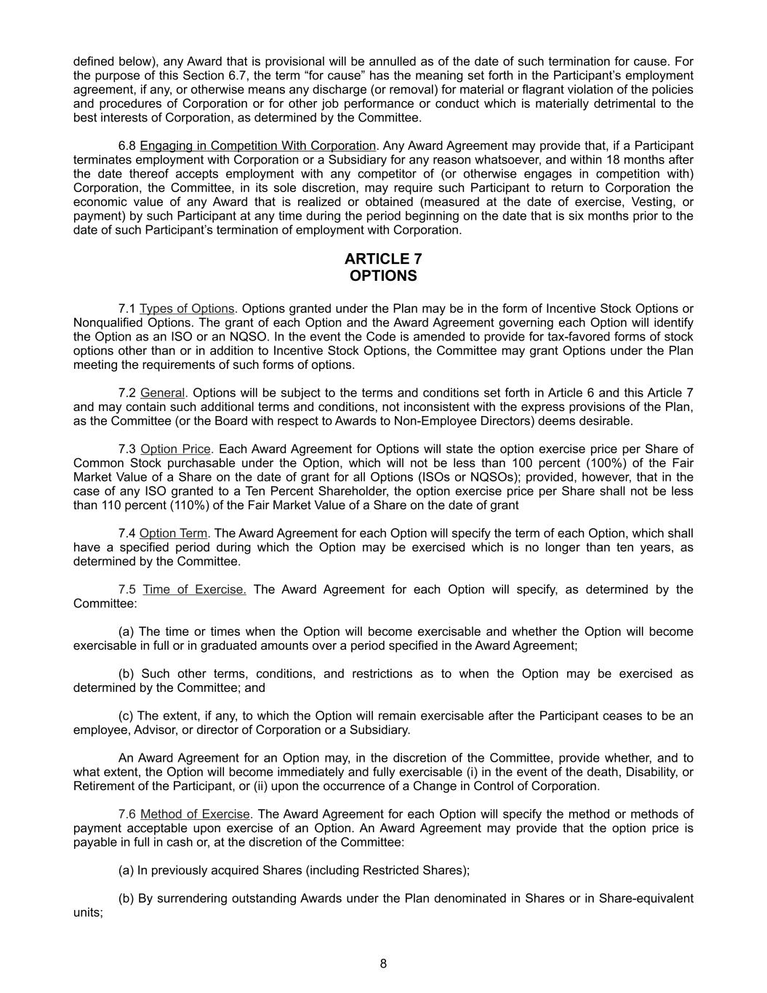
defined below), any Award that is provisional will be annulled as of the date of such termination for cause. For the purpose of this Section 6.7, the term “for cause” has the meaning set forth in the Participant’s employment agreement, if any, or otherwise means any discharge (or removal) for material or flagrant violation of the policies and procedures of Corporation or for other job performance or conduct which is materially detrimental to the best interests of Corporation, as determined by the Committee. 6.8 Engaging in Competition With Corporation. Any Award Agreement may provide that, if a Participant terminates employment with Corporation or a Subsidiary for any reason whatsoever, and within 18 months after the date thereof accepts employment with any competitor of (or otherwise engages in competition with) Corporation, the Committee, in its sole discretion, may require such Participant to return to Corporation the economic value of any Award that is realized or obtained (measured at the date of exercise, Vesting, or payment) by such Participant at any time during the period beginning on the date that is six months prior to the date of such Participant’s termination of employment with Corporation. ARTICLE 7 OPTIONS 7.1 Types of Options. Options granted under the Plan may be in the form of Incentive Stock Options or Nonqualified Options. The grant of each Option and the Award Agreement governing each Option will identify the Option as an ISO or an NQSO. In the event the Code is amended to provide for tax-favored forms of stock options other than or in addition to Incentive Stock Options, the Committee may grant Options under the Plan meeting the requirements of such forms of options. 7.2 General. Options will be subject to the terms and conditions set forth in Article 6 and this Article 7 and may contain such additional terms and conditions, not inconsistent with the express provisions of the Plan, as the Committee (or the Board with respect to Awards to Non-Employee Directors) deems desirable. 7.3 Option Price. Each Award Agreement for Options will state the option exercise price per Share of Common Stock purchasable under the Option, which will not be less than 100 percent (100%) of the Fair Market Value of a Share on the date of grant for all Options (ISOs or NQSOs); provided, however, that in the case of any ISO granted to a Ten Percent Shareholder, the option exercise price per Share shall not be less than 110 percent (110%) of the Fair Market Value of a Share on the date of grant 7.4 Option Term. The Award Agreement for each Option will specify the term of each Option, which shall have a specified period during which the Option may be exercised which is no longer than ten years, as determined by the Committee. 7.5 Time of Exercise. The Award Agreement for each Option will specify, as determined by the Committee: (a) The time or times when the Option will become exercisable and whether the Option will become exercisable in full or in graduated amounts over a period specified in the Award Agreement; (b) Such other terms, conditions, and restrictions as to when the Option may be exercised as determined by the Committee; and (c) The extent, if any, to which the Option will remain exercisable after the Participant ceases to be an employee, Advisor, or director of Corporation or a Subsidiary. An Award Agreement for an Option may, in the discretion of the Committee, provide whether, and to what extent, the Option will become immediately and fully exercisable (i) in the event of the death, Disability, or Retirement of the Participant, or (ii) upon the occurrence of a Change in Control of Corporation. 7.6 Method of Exercise. The Award Agreement for each Option will specify the method or methods of payment acceptable upon exercise of an Option. An Award Agreement may provide that the option price is payable in full in cash or, at the discretion of the Committee: (a) In previously acquired Shares (including Restricted Shares); (b) By surrendering outstanding Awards under the Plan denominated in Shares or in Share-equivalent units; 8

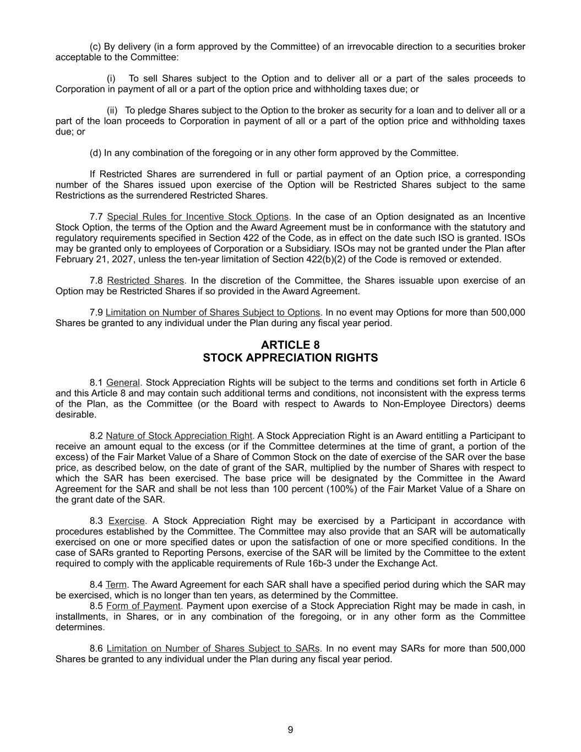
(c) By delivery (in a form approved by the Committee) of an irrevocable direction to a securities broker acceptable to the Committee: (i) To sell Shares subject to the Option and to deliver all or a part of the sales proceeds to Corporation in payment of all or a part of the option price and withholding taxes due; or (ii) To pledge Shares subject to the Option to the broker as security for a loan and to deliver all or a part of the loan proceeds to Corporation in payment of all or a part of the option price and withholding taxes due; or (d) In any combination of the foregoing or in any other form approved by the Committee. If Restricted Shares are surrendered in full or partial payment of an Option price, a corresponding number of the Shares issued upon exercise of the Option will be Restricted Shares subject to the same Restrictions as the surrendered Restricted Shares. 7.7 Special Rules for Incentive Stock Options. In the case of an Option designated as an Incentive Stock Option, the terms of the Option and the Award Agreement must be in conformance with the statutory and regulatory requirements specified in Section 422 of the Code, as in effect on the date such ISO is granted. ISOs may be granted only to employees of Corporation or a Subsidiary. ISOs may not be granted under the Plan after February 21, 2027, unless the ten-year limitation of Section 422(b)(2) of the Code is removed or extended. 7.8 Restricted Shares. In the discretion of the Committee, the Shares issuable upon exercise of an Option may be Restricted Shares if so provided in the Award Agreement. 7.9 Limitation on Number of Shares Subject to Options. In no event may Options for more than 500,000 Shares be granted to any individual under the Plan during any fiscal year period. ARTICLE 8 STOCK APPRECIATION RIGHTS 8.1 General. Stock Appreciation Rights will be subject to the terms and conditions set forth in Article 6 and this Article 8 and may contain such additional terms and conditions, not inconsistent with the express terms of the Plan, as the Committee (or the Board with respect to Awards to Non-Employee Directors) deems desirable. 8.2 Nature of Stock Appreciation Right. A Stock Appreciation Right is an Award entitling a Participant to receive an amount equal to the excess (or if the Committee determines at the time of grant, a portion of the excess) of the Fair Market Value of a Share of Common Stock on the date of exercise of the SAR over the base price, as described below, on the date of grant of the SAR, multiplied by the number of Shares with respect to which the SAR has been exercised. The base price will be designated by the Committee in the Award Agreement for the SAR and shall be not less than 100 percent (100%) of the Fair Market Value of a Share on the grant date of the SAR. 8.3 Exercise. A Stock Appreciation Right may be exercised by a Participant in accordance with procedures established by the Committee. The Committee may also provide that an SAR will be automatically exercised on one or more specified dates or upon the satisfaction of one or more specified conditions. In the case of SARs granted to Reporting Persons, exercise of the SAR will be limited by the Committee to the extent required to comply with the applicable requirements of Rule 16b-3 under the Exchange Act. 8.4 Term. The Award Agreement for each SAR shall have a specified period during which the SAR may be exercised, which is no longer than ten years, as determined by the Committee. 8.5 Form of Payment. Payment upon exercise of a Stock Appreciation Right may be made in cash, in installments, in Shares, or in any combination of the foregoing, or in any other form as the Committee determines. 8.6 Limitation on Number of Shares Subject to SARs. In no event may SARs for more than 500,000 Shares be granted to any individual under the Plan during any fiscal year period. 9

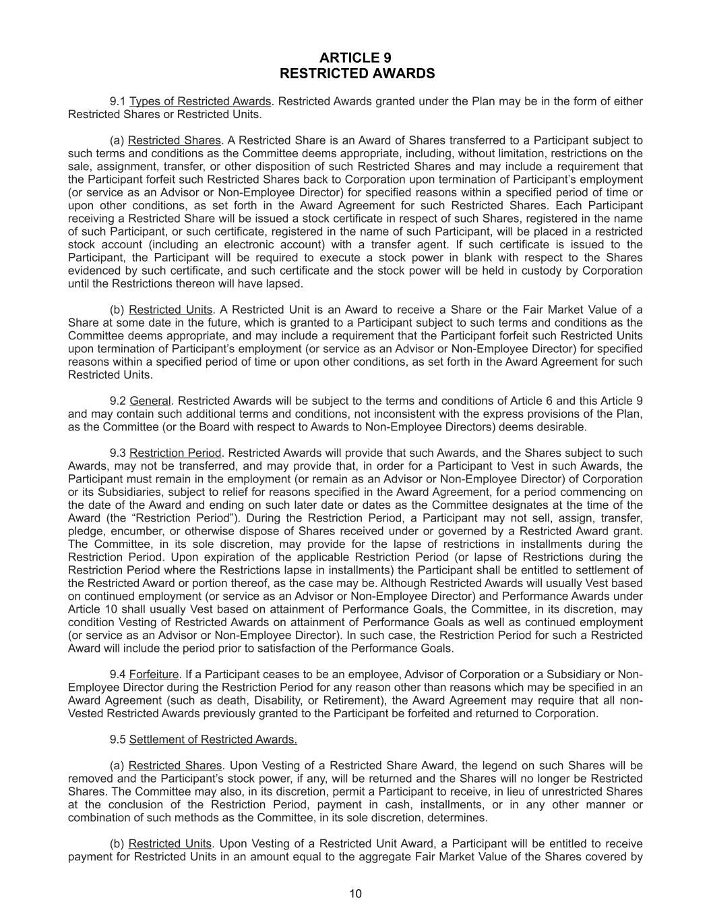
ARTICLE 9 RESTRICTED AWARDS 9.1 Types of Restricted Awards. Restricted Awards granted under the Plan may be in the form of either Restricted Shares or Restricted Units. (a) Restricted Shares. A Restricted Share is an Award of Shares transferred to a Participant subject to such terms and conditions as the Committee deems appropriate, including, without limitation, restrictions on the sale, assignment, transfer, or other disposition of such Restricted Shares and may include a requirement that the Participant forfeit such Restricted Shares back to Corporation upon termination of Participant’s employment (or service as an Advisor or Non-Employee Director) for specified reasons within a specified period of time or upon other conditions, as set forth in the Award Agreement for such Restricted Shares. Each Participant receiving a Restricted Share will be issued a stock certificate in respect of such Shares, registered in the name of such Participant, or such certificate, registered in the name of such Participant, will be placed in a restricted stock account (including an electronic account) with a transfer agent. If such certificate is issued to the Participant, the Participant will be required to execute a stock power in blank with respect to the Shares evidenced by such certificate, and such certificate and the stock power will be held in custody by Corporation until the Restrictions thereon will have lapsed. (b) Restricted Units. A Restricted Unit is an Award to receive a Share or the Fair Market Value of a Share at some date in the future, which is granted to a Participant subject to such terms and conditions as the Committee deems appropriate, and may include a requirement that the Participant forfeit such Restricted Units upon termination of Participant’s employment (or service as an Advisor or Non-Employee Director) for specified reasons within a specified period of time or upon other conditions, as set forth in the Award Agreement for such Restricted Units. 9.2 General. Restricted Awards will be subject to the terms and conditions of Article 6 and this Article 9 and may contain such additional terms and conditions, not inconsistent with the express provisions of the Plan, as the Committee (or the Board with respect to Awards to Non-Employee Directors) deems desirable. 9.3 Restriction Period. Restricted Awards will provide that such Awards, and the Shares subject to such Awards, may not be transferred, and may provide that, in order for a Participant to Vest in such Awards, the Participant must remain in the employment (or remain as an Advisor or Non-Employee Director) of Corporation or its Subsidiaries, subject to relief for reasons specified in the Award Agreement, for a period commencing on the date of the Award and ending on such later date or dates as the Committee designates at the time of the Award (the “Restriction Period”). During the Restriction Period, a Participant may not sell, assign, transfer, pledge, encumber, or otherwise dispose of Shares received under or governed by a Restricted Award grant. The Committee, in its sole discretion, may provide for the lapse of restrictions in installments during the Restriction Period. Upon expiration of the applicable Restriction Period (or lapse of Restrictions during the Restriction Period where the Restrictions lapse in installments) the Participant shall be entitled to settlement of the Restricted Award or portion thereof, as the case may be. Although Restricted Awards will usually Vest based on continued employment (or service as an Advisor or Non-Employee Director) and Performance Awards under Article 10 shall usually Vest based on attainment of Performance Goals, the Committee, in its discretion, may condition Vesting of Restricted Awards on attainment of Performance Goals as well as continued employment (or service as an Advisor or Non-Employee Director). In such case, the Restriction Period for such a Restricted Award will include the period prior to satisfaction of the Performance Goals. 9.4 Forfeiture. If a Participant ceases to be an employee, Advisor of Corporation or a Subsidiary or Non- Employee Director during the Restriction Period for any reason other than reasons which may be specified in an Award Agreement (such as death, Disability, or Retirement), the Award Agreement may require that all non- Vested Restricted Awards previously granted to the Participant be forfeited and returned to Corporation. 9.5 Settlement of Restricted Awards. (a) Restricted Shares. Upon Vesting of a Restricted Share Award, the legend on such Shares will be removed and the Participant’s stock power, if any, will be returned and the Shares will no longer be Restricted Shares. The Committee may also, in its discretion, permit a Participant to receive, in lieu of unrestricted Shares at the conclusion of the Restriction Period, payment in cash, installments, or in any other manner or combination of such methods as the Committee, in its sole discretion, determines. (b) Restricted Units. Upon Vesting of a Restricted Unit Award, a Participant will be entitled to receive payment for Restricted Units in an amount equal to the aggregate Fair Market Value of the Shares covered by 10

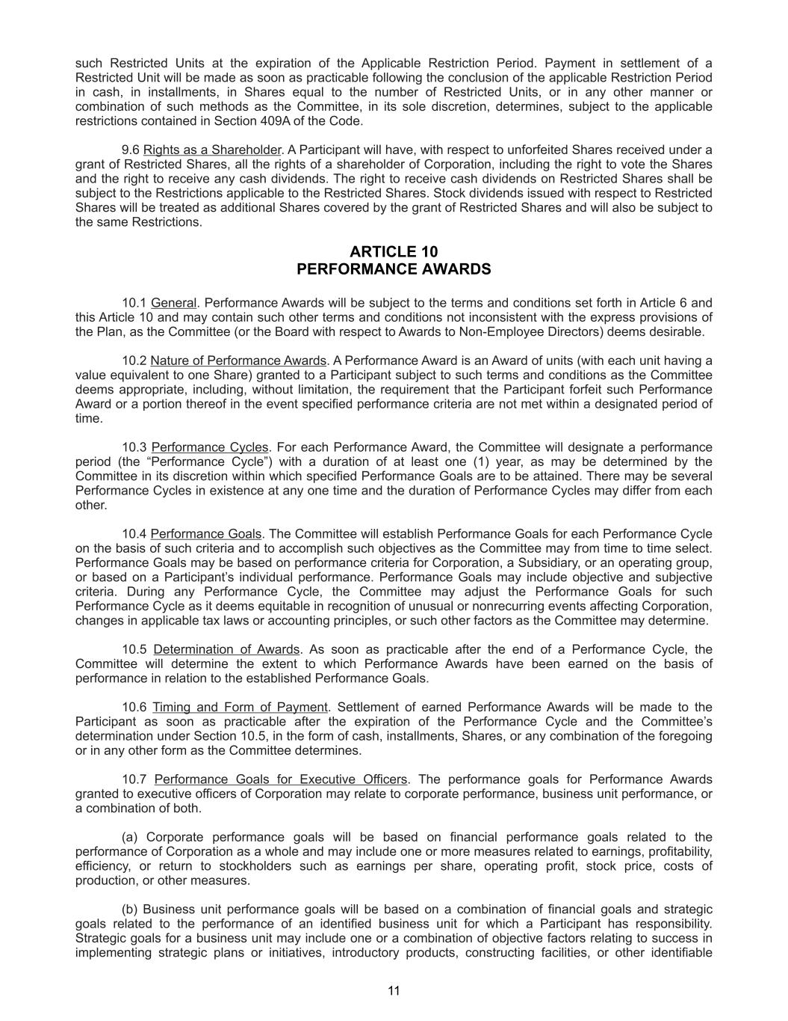
such Restricted Units at the expiration of the Applicable Restriction Period. Payment in settlement of a Restricted Unit will be made as soon as practicable following the conclusion of the applicable Restriction Period in cash, in installments, in Shares equal to the number of Restricted Units, or in any other manner or combination of such methods as the Committee, in its sole discretion, determines, subject to the applicable restrictions contained in Section 409A of the Code. 9.6 Rights as a Shareholder. A Participant will have, with respect to unforfeited Shares received under a grant of Restricted Shares, all the rights of a shareholder of Corporation, including the right to vote the Shares and the right to receive any cash dividends. The right to receive cash dividends on Restricted Shares shall be subject to the Restrictions applicable to the Restricted Shares. Stock dividends issued with respect to Restricted Shares will be treated as additional Shares covered by the grant of Restricted Shares and will also be subject to the same Restrictions. ARTICLE 10 PERFORMANCE AWARDS 10.1 General. Performance Awards will be subject to the terms and conditions set forth in Article 6 and this Article 10 and may contain such other terms and conditions not inconsistent with the express provisions of the Plan, as the Committee (or the Board with respect to Awards to Non-Employee Directors) deems desirable. 10.2 Nature of Performance Awards. A Performance Award is an Award of units (with each unit having a value equivalent to one Share) granted to a Participant subject to such terms and conditions as the Committee deems appropriate, including, without limitation, the requirement that the Participant forfeit such Performance Award or a portion thereof in the event specified performance criteria are not met within a designated period of time. 10.3 Performance Cycles. For each Performance Award, the Committee will designate a performance period (the “Performance Cycle”) with a duration of at least one (1) year, as may be determined by the Committee in its discretion within which specified Performance Goals are to be attained. There may be several Performance Cycles in existence at any one time and the duration of Performance Cycles may differ from each other. 10.4 Performance Goals. The Committee will establish Performance Goals for each Performance Cycle on the basis of such criteria and to accomplish such objectives as the Committee may from time to time select. Performance Goals may be based on performance criteria for Corporation, a Subsidiary, or an operating group, or based on a Participant’s individual performance. Performance Goals may include objective and subjective criteria. During any Performance Cycle, the Committee may adjust the Performance Goals for such Performance Cycle as it deems equitable in recognition of unusual or nonrecurring events affecting Corporation, changes in applicable tax laws or accounting principles, or such other factors as the Committee may determine. 10.5 Determination of Awards. As soon as practicable after the end of a Performance Cycle, the Committee will determine the extent to which Performance Awards have been earned on the basis of performance in relation to the established Performance Goals. 10.6 Timing and Form of Payment. Settlement of earned Performance Awards will be made to the Participant as soon as practicable after the expiration of the Performance Cycle and the Committee’s determination under Section 10.5, in the form of cash, installments, Shares, or any combination of the foregoing or in any other form as the Committee determines. 10.7 Performance Goals for Executive Officers. The performance goals for Performance Awards granted to executive officers of Corporation may relate to corporate performance, business unit performance, or a combination of both. (a) Corporate performance goals will be based on financial performance goals related to the performance of Corporation as a whole and may include one or more measures related to earnings, profitability, efficiency, or return to stockholders such as earnings per share, operating profit, stock price, costs of production, or other measures. (b) Business unit performance goals will be based on a combination of financial goals and strategic goals related to the performance of an identified business unit for which a Participant has responsibility. Strategic goals for a business unit may include one or a combination of objective factors relating to success in implementing strategic plans or initiatives, introductory products, constructing facilities, or other identifiable 11

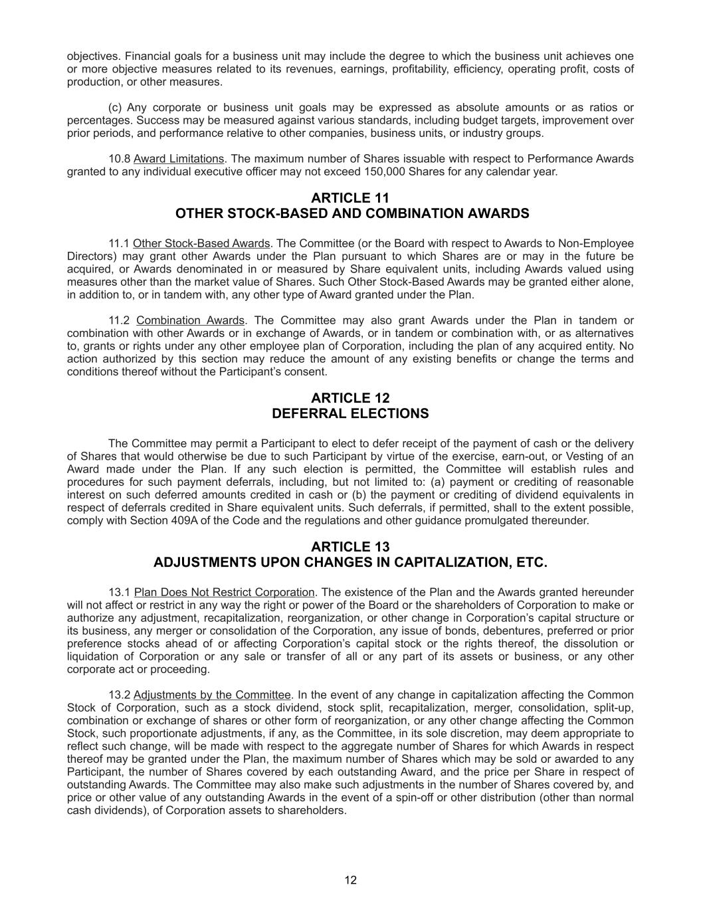
objectives. Financial goals for a business unit may include the degree to which the business unit achieves one or more objective measures related to its revenues, earnings, profitability, efficiency, operating profit, costs of production, or other measures. (c) Any corporate or business unit goals may be expressed as absolute amounts or as ratios or percentages. Success may be measured against various standards, including budget targets, improvement over prior periods, and performance relative to other companies, business units, or industry groups. 10.8 Award Limitations. The maximum number of Shares issuable with respect to Performance Awards granted to any individual executive officer may not exceed 150,000 Shares for any calendar year. ARTICLE 11 OTHER STOCK-BASED AND COMBINATION AWARDS 11.1 Other Stock-Based Awards. The Committee (or the Board with respect to Awards to Non-Employee Directors) may grant other Awards under the Plan pursuant to which Shares are or may in the future be acquired, or Awards denominated in or measured by Share equivalent units, including Awards valued using measures other than the market value of Shares. Such Other Stock-Based Awards may be granted either alone, in addition to, or in tandem with, any other type of Award granted under the Plan. 11.2 Combination Awards. The Committee may also grant Awards under the Plan in tandem or combination with other Awards or in exchange of Awards, or in tandem or combination with, or as alternatives to, grants or rights under any other employee plan of Corporation, including the plan of any acquired entity. No action authorized by this section may reduce the amount of any existing benefits or change the terms and conditions thereof without the Participant’s consent. ARTICLE 12 DEFERRAL ELECTIONS The Committee may permit a Participant to elect to defer receipt of the payment of cash or the delivery of Shares that would otherwise be due to such Participant by virtue of the exercise, earn-out, or Vesting of an Award made under the Plan. If any such election is permitted, the Committee will establish rules and procedures for such payment deferrals, including, but not limited to: (a) payment or crediting of reasonable interest on such deferred amounts credited in cash or (b) the payment or crediting of dividend equivalents in respect of deferrals credited in Share equivalent units. Such deferrals, if permitted, shall to the extent possible, comply with Section 409A of the Code and the regulations and other guidance promulgated thereunder. ARTICLE 13 ADJUSTMENTS UPON CHANGES IN CAPITALIZATION, ETC. 13.1 Plan Does Not Restrict Corporation. The existence of the Plan and the Awards granted hereunder will not affect or restrict in any way the right or power of the Board or the shareholders of Corporation to make or authorize any adjustment, recapitalization, reorganization, or other change in Corporation’s capital structure or its business, any merger or consolidation of the Corporation, any issue of bonds, debentures, preferred or prior preference stocks ahead of or affecting Corporation’s capital stock or the rights thereof, the dissolution or liquidation of Corporation or any sale or transfer of all or any part of its assets or business, or any other corporate act or proceeding. 13.2 Adjustments by the Committee. In the event of any change in capitalization affecting the Common Stock of Corporation, such as a stock dividend, stock split, recapitalization, merger, consolidation, split-up, combination or exchange of shares or other form of reorganization, or any other change affecting the Common Stock, such proportionate adjustments, if any, as the Committee, in its sole discretion, may deem appropriate to reflect such change, will be made with respect to the aggregate number of Shares for which Awards in respect thereof may be granted under the Plan, the maximum number of Shares which may be sold or awarded to any Participant, the number of Shares covered by each outstanding Award, and the price per Share in respect of outstanding Awards. The Committee may also make such adjustments in the number of Shares covered by, and price or other value of any outstanding Awards in the event of a spin-off or other distribution (other than normal cash dividends), of Corporation assets to shareholders. 12

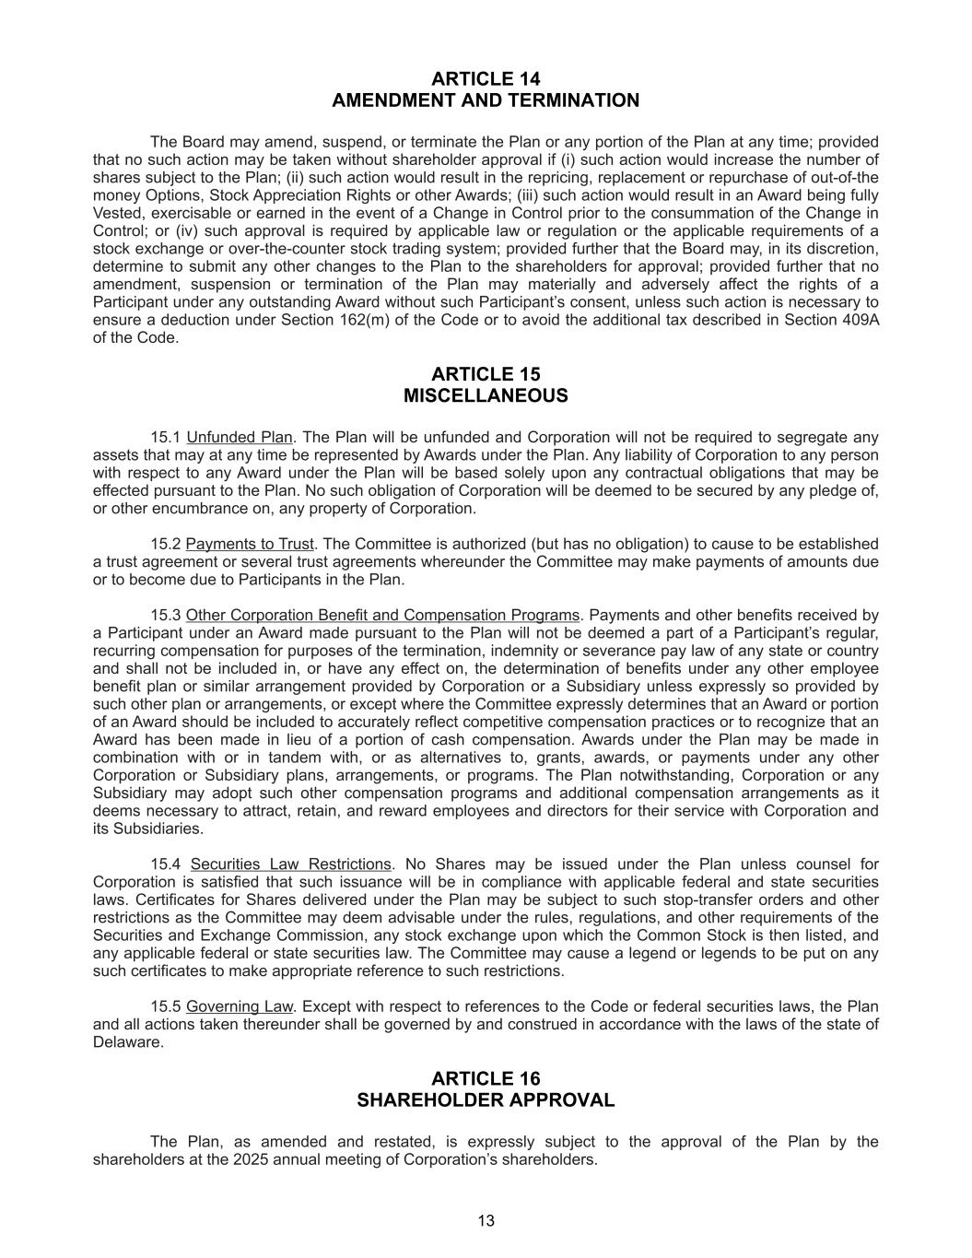
ARTICLE 14 AMENDMENT AND TERMINATION The Board may amend, suspend, or terminate the Plan or any portion of the Plan at any time; provided that no such action may be taken without shareholder approval if (i) such action would increase the number of shares subject to the Plan; (ii) such action would result in the repricing, replacement or repurchase of out-of-the money Options, Stock Appreciation Rights or other Awards; (iii) such action would result in an Award being fully Vested, exercisable or earned in the event of a Change in Control prior to the consummation of the Change in Control; or (iv) such approval is required by applicable law or regulation or the applicable requirements of a stock exchange or over-the-counter stock trading system; provided further that the Board may, in its discretion, determine to submit any other changes to the Plan to the shareholders for approval; provided further that no amendment, suspension or termination of the Plan may materially and adversely affect the rights of a Participant under any outstanding Award without such Participant’s consent, unless such action is necessary to ensure a deduction under Section 162(m) of the Code or to avoid the additional tax described in Section 409A of the Code. ARTICLE 15 MISCELLANEOUS 15.1 Unfunded Plan. The Plan will be unfunded and Corporation will not be required to segregate any assets that may at any time be represented by Awards under the Plan. Any liability of Corporation to any person with respect to any Award under the Plan will be based solely upon any contractual obligations that may be effected pursuant to the Plan. No such obligation of Corporation will be deemed to be secured by any pledge of, or other encumbrance on, any property of Corporation. 15.2 Payments to Trust. The Committee is authorized (but has no obligation) to cause to be established a trust agreement or several trust agreements whereunder the Committee may make payments of amounts due or to become due to Participants in the Plan. 15.3 Other Corporation Benefit and Compensation Programs. Payments and other benefits received by a Participant under an Award made pursuant to the Plan will not be deemed a part of a Participant’s regular, recurring compensation for purposes of the termination, indemnity or severance pay law of any state or country and shall not be included in, or have any effect on, the determination of benefits under any other employee benefit plan or similar arrangement provided by Corporation or a Subsidiary unless expressly so provided by such other plan or arrangements, or except where the Committee expressly determines that an Award or portion of an Award should be included to accurately reflect competitive compensation practices or to recognize that an Award has been made in lieu of a portion of cash compensation. Awards under the Plan may be made in combination with or in tandem with, or as alternatives to, grants, awards, or payments under any other Corporation or Subsidiary plans, arrangements, or programs. The Plan notwithstanding, Corporation or any Subsidiary may adopt such other compensation programs and additional compensation arrangements as it deems necessary to attract, retain, and reward employees and directors for their service with Corporation and its Subsidiaries. 15.4 Securities Law Restrictions. No Shares may be issued under the Plan unless counsel for Corporation is satisfied that such issuance will be in compliance with applicable federal and state securities laws. Certificates for Shares delivered under the Plan may be subject to such stop-transfer orders and other restrictions as the Committee may deem advisable under the rules, regulations, and other requirements of the Securities and Exchange Commission, any stock exchange upon which the Common Stock is then listed, and any applicable federal or state securities law. The Committee may cause a legend or legends to be put on any such certificates to make appropriate reference to such restrictions. 15.5 Governing Law. Except with respect to references to the Code or federal securities laws, the Plan and all actions taken thereunder shall be governed by and construed in accordance with the laws of the state of Delaware. ARTICLE 16 SHAREHOLDER APPROVAL The Plan, as amended and restated, is expressly subject to the approval of the Plan by the shareholders at the 2025 annual meeting of Corporation’s shareholders. 13

