SCHEDULE 14A
Proxy Statement Pursuant to Section 14(a)
of the Securities Exchange Act of 1934

Filed by the Registrant ☐

Filed by a Party other than the Registrant ☑

Check the appropriate box:

- Preliminary Proxy Statement
- Confidential, for Use of the Commission Only (as permitted by Rule 14a-6(e)(2))
- Definitive Proxy Statement
- Definitive Additional Materials
- Soliciting Material Under Rule 14a-12

OraSure Technologies, Inc.

(Name of Registrant as Specified In Its Charter)

Altai Capital Management, L.P.

Altai Capital Management, LLC
Altai Capital Osprey, LLC
Rishi Bajaj
John Bertrand

(Name of Person(s) Filing Proxy Statement, if other than the Registrant)

Payment of Filing Fee (Check the appropriate box):

- No fee required.

- Fee paid previously with preliminary materials.

- Fee computed on table in exhibit required by Item 25(b) per Exchange Act Rules 14a-6(i)(1) and 0-11.



Altai Capital Management Issues Letter to OraSure Board Outlining Five-Pillar Case for Change in Response to Significant and Continued Underperformance

Calls on Company to Reach a Fair Settlement that Appoints Altai Nominees Rishi Bajaj and John Bertrand to the Board

LOS ANGELES, CA, March 17, 2026 -- Altai Capital Management, L.P. ("Altai"), one of the largest shareholders and the beneficial owners of approximately 5% of the outstanding common stock of OraSure Technologies, Inc. (“OraSure” or the “Company”) (NASDAQ: OSUR), today announced that it has delivered a letter to the OraSure Board of Directors (the “Board”) outlining a five-pillar case for why change is necessary to preserve and deliver value for its investors.

In the letter, Altai calls on the OraSure Board to reach a fair settlement that results in the appointment of Altai’s highly-qualified director nominees, Rishi Bajaj and John Bertrand, to the Board.

Highlights of the letter, which can be found in full here, include:

- Chronic Underperformance. OraSure’s share price has dramatically underperformed comparable companies and broader indices over both five- and ten-year periods. Recent underperformance has been driven by repeated operational and strategic failures under the current management team—failures that occurred on the Board’s watch. Despite this track record, the Company continues to burn cash pursuing speculative diagnostics investments to the detriment of shareholders.

- A Board Without Skin in the Game. Independent directors collectively own less than 1% of shares outstanding yet collect over $250,000 each per year in compensation. They bear little financial risk for decisions that have destroyed shareholder value. Shareholders who face the very real risk of losing money on their investment deserve a larger voice on the Board.

- Pay Without Performance. Over 90% of CEO Carrie Eglinton Manner’s compensation is not tied to share price performance. She has earned an estimated $15 million over her tenure while shareholders have lost 60% of their investment since 2023. Her incentives are plainly misaligned with shareholder interests.

- The Imperative for a Strategic Review. OraSure must evaluate a sale of the entire business alongside its current plan. We will represent and advocate for all shareholder interests in this process upon our appointment to the Board to ensure that the outcome delivers the best possible returns to shareholders.

- Nominees With a Track Record of Results. Rishi Bajaj led ContextLogic’s transformation from a company burning $80 million of cash per quarter to one that completed a $907.5 million acquisition, producing a share price increase of over 120%. John Bertrand built the company behind the first FDA-cleared autonomous AI diagnostic solution in healthcare. Both nominees will seek to align their compensation directly with shareholder returns.

As previously announced, Altai has formally nominated Rishi Bajaj and John Bertrand for election at the 2026 Annual Meeting of Shareholders.


About Altai Capital Management

Altai Capital Management is a technology-focused investment firm founded in 2009 by Rishi Bajaj. Altai Capital makes long-term investments across a diverse range of financial instruments, including debt, private equity, venture capital, and publicly traded securities. To learn more, visit www.altai.com

Disclaimers

This press release and the opinions herein are for general information only, and are not intended to be, nor should they be construed as, an offer to sell or a solicitation of an offer to buy any security, a recommendation to purchase or sell any security, or legal, financial, tax, investment, or other advice.

Altai Capital Management, L.P., Altai Capital Management, LLC, Altai Capital Osprey, LLC, Rishi Bajaj and John Bertrand (collectively, the “Participants”) intend to file with the SEC a definitive proxy statement and accompanying form of proxy to be used in connection with the solicitation of proxies from the stockholders of OraSure Technologies, Inc. Stockholders are advised to read the definitive proxy statement and other documents related to the solicitation of proxies by the Participants when they become available, as they will contain important information, including additional information related to the Participants. The definitive proxy statement and an accompanying proxy card will be furnished to OraSure Technologies, Inc. stockholders and will be, along with other relevant documents, available at no charge on the SEC website at http://www.sec.gov/.

Information about the Participants and a description of their direct or indirect interests, by security holdings or otherwise, is contained in Exhibit 1 to the Schedule 14A filed by the Participants with the SEC on March 17, 2026. This document is available free of charge from the source indicated above.

Media Contact:

ASC Advisors

Taylor Ingraham / Max Rayden

tingraham@ascadvisors.com / mrayden@ascadvisors.com

###

2

March 17, 2026

VIA EMAIL

Mr. John P. Kenny

Chairman of the Board
OraSure Technologies, Inc.
150 Webster St.

Bethlehem, PA 18015

CC: Board of Directors of OraSure

Dear Mr. Kenny and Members of the Board:

Altai Capital Management owns approximately 5% of OraSure Technologies, making us one of the Company’s largest shareholders.¹ On December 17, 2025, we wrote to the Board stating our intention to nominate two candidates—John Bertrand, Co-Founder and former CEO of Digital Diagnostics, and myself, Rishi Bajaj, President and CIO of Altai Capital—for election at the 2026 Annual Meeting. Since that letter, Altai Capital has submitted formal

nominations.² We will be asking all shareholders to vote in favor of our nominees at the 2026 Annual Meeting. Please see Exhibits A and B, respectively, for my and Mr. Bertrand’s biographies.

Our case for change at OraSure rests on five pillars:

- Chronic Underperformance. OraSure’s share price has dramatically underperformed comparable companies and broader indices over both five- and ten-year periods. Recent underperformance has been driven by repeated operational and strategic failures under the current management team—failures that occurred on the Board’s watch. Despite this track record, the Company continues to burn cash pursuing speculative diagnostics investments to the detriment of shareholders.

- A Board Without Skin in the Game. Independent directors collectively own less than 1% of shares outstanding yet collect over $250,000 each per year in compensation. They bear little financial risk for decisions that have destroyed shareholder value. Shareholders who face the very real risk of losing money on their investment deserve a larger voice on the Board.

- Pay Without Performance. Over 90% of CEO Carrie Eglinton Manner’s compensation is not tied to share price performance. She has earned an estimated $15 million over her tenure while shareholders have lost 60% of their investment since 2023. Her incentives are plainly misaligned with shareholder interests.

- The Imperative for a Strategic Review. OraSure must evaluate a sale of the entire business alongside its current plan. We will represent and advocate for all shareholder interests in this process upon our appointment to the Board to ensure that the outcome delivers the best possible returns to shareholders.

- Nominees With a Track Record of Results. Rishi Bajaj led ContextLogic’s transformation from a company burning $80 million of cash per quarter to one that completed a $907.5 million acquisition, producing a share price increase of over 120%. John Bertrand built the company behind the first FDA-cleared autonomous AI diagnostic solution in healthcare. Both nominees will seek to align their compensation directly with shareholder returns.

The facts and events shown throughout this letter are clear. We present them so that shareholders can judge for themselves how OraSure arrived at this juncture.

_________________________
- Altai Capital Management is referred to in this letter as “Altai” or “Altai Capital.” OraSure Technologies, Inc. (ticker: OSUR) is referred to as “OraSure” or the “Company.”

  - The Board of Directors of OraSure is referred to in this letter as the “Board of Directors” or the “Board.”

3

- Chronic Underperformance

OraSure’s stock price is down 67% and 56% respectively on a 5-year and 10-year trailing basis. Over the past 5 years and 10 years, OraSure has dramatically underperformed its peers and the broader equity indices.

Most of the loss in value over the past two years was due to management failures under the Board’s watch. This is simply unacceptable and shareholders deserve answers and accountability.

Price Performance Graph: OraSure vs. Relevant Indices³
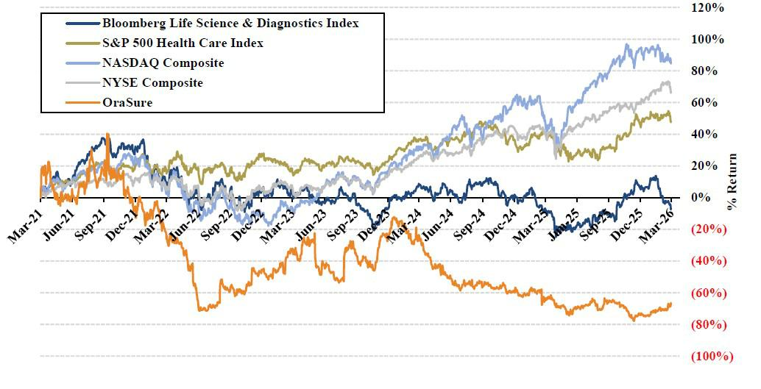

Price Performance: OraSure vs. Relevant Indices⁴
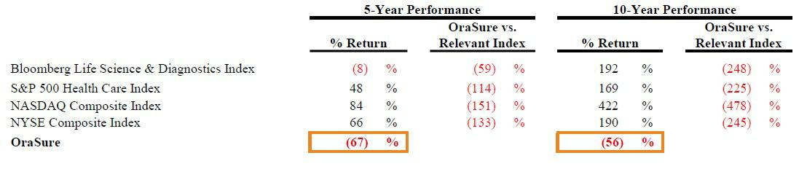

____________________________

- Performance shown throughout this letter is presented as of 03/06/26 unless otherwise noted. The Price Performance Graph reflects the period 03/08/21 – 03/06/26. Data for the Bloomberg US 3000 Life Science & Diagnostics Price Return Index, S&P Health Care Index, NASDAQ Composite Index and the NYSE Composite Index assume reinvestment of dividends.

- The 5-year and 10-year performance is calculated for the period 03/08/21 – 03/06/26 and 03/07/16 – 03/06/26, respectively. Data for the Bloomberg US 3000 Life Science & Diagnostics Price Return Index, S&P Health Care Index, NASDAQ Composite Index and the NYSE Composite Index assume reinvestment of dividends. OraSure vs. Relevant Index performance figures may not equal the calculated differences due to rounding.

4

A $290 Million Question

On June 4, 2022, Carrie Eglinton Manner became CEO of OraSure. At the close of 2022, OraSure had grown its cash balance from $111 million primarily by winding down its COVID testing business, collecting outstanding receivables, and selling remaining inventory. OraSure ended 2023 with $290 million of cash on its balance sheet ($3.94 per share) and its shares trading at $8.20.

This was an inflection point. The COVID windfall presented the Board with strategic choices. OraSure could have returned the cash to shareholders. It could have purchased established businesses with revenues and product volumes that could utilize OraSure’s excess manufacturing capacity. It could have pursued a sale of the business at a moment of financial strength. But instead, it chose to invest in speculative, subscale companies—and it invested poorly.

In January 2024, OraSure invested $30 million in Sapphiros, a startup diagnostic platform company with no commercial products on the market. The Company told investors that “distribution of Sapphiros’ products is expected to accelerate revenue growth in OraSure’s core business beginning in
2025.”⁵ That growth never came. By year-end 2025, OraSure’s core business (“non-COVID revenue”) had declined 27%, and the Company has not provided a recent update on the status of its Sapphiros investment or the revenue it was expected to generate.

Financial and Valuation Summary: 2022-2025⁶
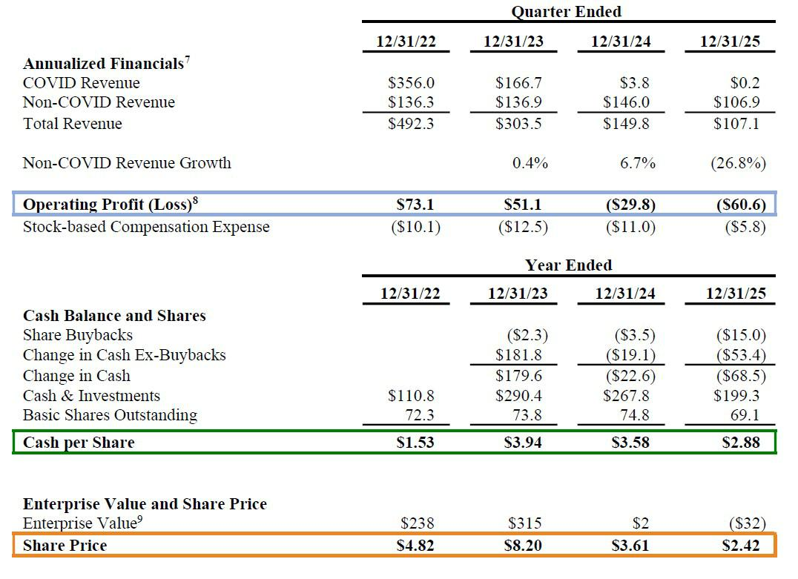

__________________________

- Source: OraSure press release, January 4, 2024.
- All share counts and dollar figures, except share prices, presented throughout this letter are in millions unless otherwise noted.

⁷ Annualized Financials are calculated by multiplying quarterly reported results by four, unless stated.

- Operating Profit (Loss) is calculated as non-GAAP operating loss less stock-based compensation plus D&A less capex, excluding purchases of property and equipment under government contracts. Annualized Operating Profit (Loss) for the quarter ended 12/31/22 uses annualized figures but deducts full year 2022 capex excluding purchases of property and equipment under government contracts.
- Enterprise value is calculated using basic shares outstanding with no value attributed to the Sapphiros investment.

5

Doubling Down

By the end of 2024, cash had declined to $268 million and OraSure’s share price had dropped 56% over the year to

$3.61. In Q4 2024, the Company’s non-COVID business was generating annualized revenue of $146 million—essentially flat with Ms. Eglinton Manner’s first quarter as CEO—while losing approximately $7.5 million per quarter.¹⁰ A board focused on accountability would have paused and reassessed. This Board doubled down.

Prior to closing its 2024 fourth quarter, OraSure committed at least $25 million to acquire Sherlock Biosciences, an early-stage diagnostics company with no commercial products.¹¹ The acquisition is troubling not only on its merits, but also because of the circumstances surrounding it.

Mara Aspinall joined the Board of OraSure in June 2017. On March 8, 2022, Illumina Ventures participated in an $80 million funding round for Sherlock Biosciences. On November 8, 2022, Ms. Aspinall became Chair of OraSure’s Board. On September 21, 2023, she became a Partner at Illumina Ventures. On December 19, 2024, OraSure, chaired by Ms. Aspinall, agreed to purchase Sherlock—a company backed by Ms. Aspinall’s own venture fund—for

$5 million upfront plus the commitment to fund at least $20 million in R&D costs.¹² The venture funds that had previously backed Sherlock, including Illumina Ventures, had themselves declined to invest further despite Sherlock purportedly targeting an estimated $1.5 billion growth market. OraSure stepped in where Sherlock’s existing investors would not.

The question of whether Ms. Aspinall’s dual role—as Board Chair of the buyer and as a Partner of an investor in the company being acquired—was properly disclosed and managed remains unanswered. The Company has not detailed Ms. Aspinall’s involvement in the acquisition process, nor confirmed whether she recused herself from the Board’s deliberations and vote related to the transaction. OraSure has also not explained why Sherlock, if its prospects were so compelling, was not marketed through a competitive sale process that could have attracted a buyer willing to pay more than $5 million upfront. These are important questions that require answers.

Altai Capital began conversations with OraSure regarding Board representation in November 2024. Tellingly, Ms. Aspinall resigned from the Board on October 28, 2025, after our ongoing discussions made clear that we would formally seek to have her replaced at the upcoming Annual Meeting if we could not reach an agreement. Five of the six Board members who approved the Sherlock acquisition, including Ms. Eglinton Manner, remain on the Board today. They continue to bear responsibility for their oversight (or lack thereof) in the Sherlock acquisition process and should be held accountable.

We note that Sherlock’s applications are currently under FDA review with the potential for approval in the first half of 2026. If elected, John Bertrand and I will evaluate Sherlock’s prospects with open minds. We would be delighted to change our assessment if the facts change for the better. But hope is not a strategy, and it is certainly not a reason to deny shareholders a voice on this Board.

Significant OraSure Strategic Transactions Since Ms. Carrie Eglinton Manner Became CEO
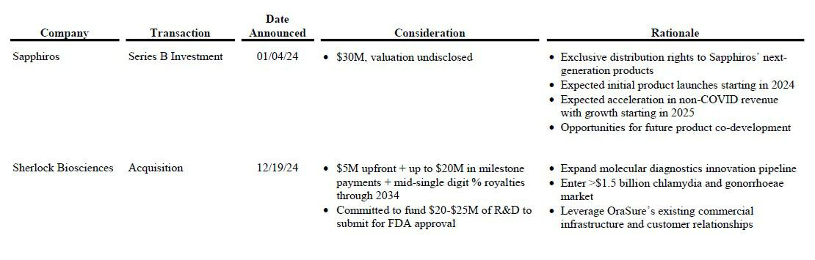

________________________________

- $7.5 million operating loss in Q4 2024 is calculated as non-GAAP operating loss less stock-based compensation plus D&A less capex.

- Sherlock Biosciences, Inc. is referred to as “Sherlock Biosciences” or “Sherlock” throughout this letter.

- If Sherlock reaches certain milestones, OraSure must pay up to $20 million in additional consideration.

6

The Bill Comes Due

By year-end 2025, OraSure’s cash had diminished to $199 million ($2.88 per share)—a decline of over $90 million since the end of 2023. Non-COVID revenue had fallen to an annualized rate of $107 million, 27% below its 2024 run rate. Excluding approximately $5 million in share repurchases last quarter, cash is declining at roughly $12 million per quarter, driven by operating losses of approximately $15 million per quarter, which include $2–3 million in quarterly stock-based compensation.¹³ The trajectory is clear.

On the Company’s most recent earnings call, CFO Ken McGrath made a remarkable admission: OraSure is operating at approximately 30% manufacturing capacity. He stated that the Company does not expect to reach operating cash flow breakeven until 2027, “driven by our expected return to revenue growth, including contributions from our anticipated product launches.” Shareholders must endure at least another year of cash burn while hoping that Sherlock succeeds—a product that, as of today, has not received FDA approval and generates zero revenue.

This is the central strategic failure, and it deserves to be stated plainly. A company running at 30% capacity should acquire established businesses that can immediately absorb excess manufacturing capacity and improve profitability. Instead, OraSure pursued speculative, early-stage ventures with no near-term production volumes. Every dollar spent on companies that do not use OraSure’s existing infrastructure is a dollar that deepens, rather than addresses, the Company’s core problem. The true cost of these investments substantially exceeds their headline prices, and any future profit carries significant execution risk that investors should not be asked to underwrite indefinitely.

A change of strategy is warranted. We believe it is imperative for the Company to reduce its cash burn and safeguard itself against further misuses of cash, including additional value-destructive investments and acquisitions. Shareholder representation on the Board is critical to ensure that OraSure generates future value through more disciplined capital allocation or the sale of the entire business.

____________________________

- Cash declined by $17 million last quarter, including $5 million in stock buybacks and $3.6 million paid for OraSure’s acquisition of BioMedomics, Inc. Operating losses are defined as non-GAAP operating losses less stock-based compensation plus D&A less capex.

7

OraSure Share Price and Selected Events¹⁴
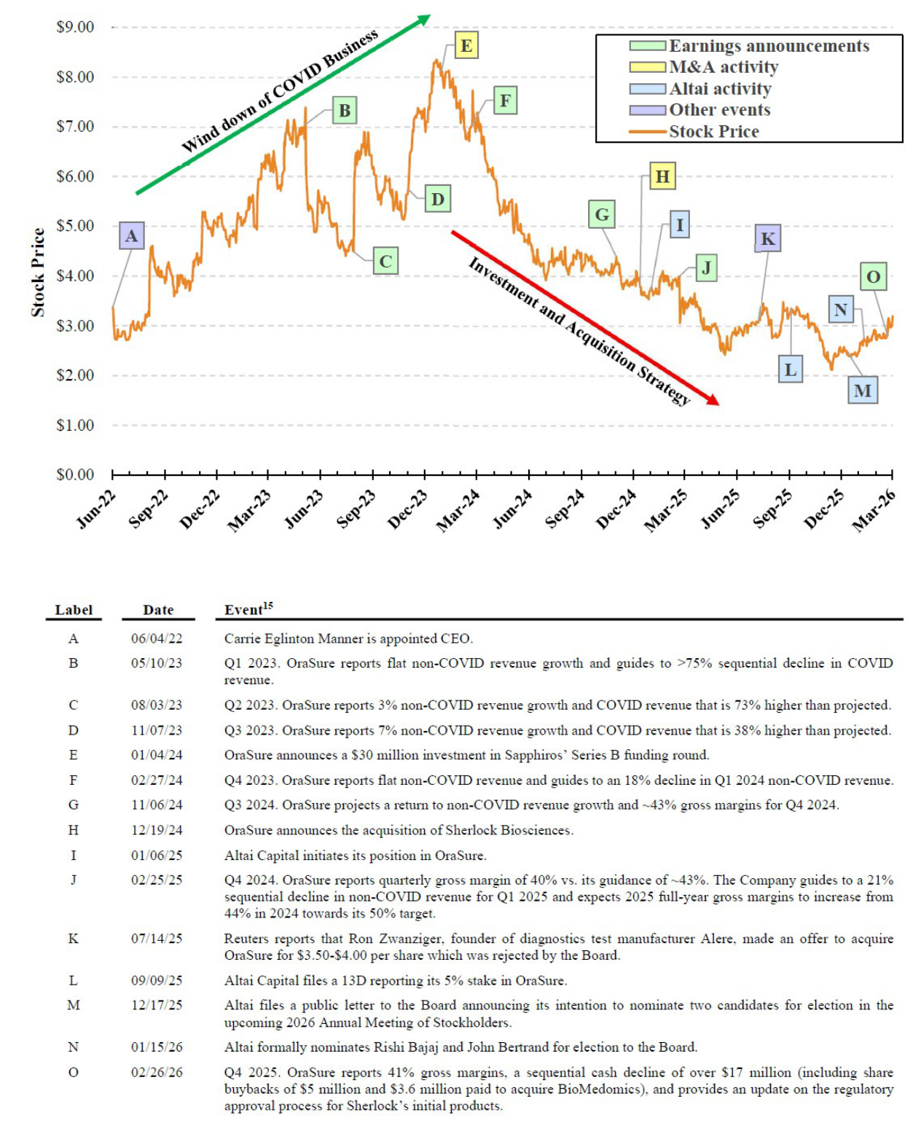

- Price event graph reflects select events during the period 06/04/22, the date that Ms. Eglinton Manner was appointed CEO, through 03/06/26.

- All growth figures, unless stated, are year-over-year.

8

- A Board Without Skin in the Game

Independent OraSure directors cumulatively own less than 1% of shares outstanding. Three of the five current independent directors oversaw the Sapphiros investment; four of the five were on the Board for the Sherlock acquisition. Together, these transactions are expected to cost shareholders over $55 million—not counting milestone and royalty payments or the additional operating losses attributable to underutilized manufacturing capacity. Unlike the shareholders they are supposed to represent, these directors bear virtually no financial risk for decisions that have destroyed value.

Despite this track record, the Board in 2025 increased its own annual stock-based awards by over 75%, from $105,000 to $185,000. Board members now earn annual compensation exceeding $250,000. Lelio Marmora and Nancy Gagliano have each earned over $1 million for their half-decade of service—a period during which shareholders have watched the value of their investment evaporate. The Board has been richly compensated for overseeing the destruction of shareholder value. That is not governance; it is a misalignment of interests that demands correction.

The contrast with Altai Capital is instructive. Altai owns approximately 5% of OraSure’s outstanding shares—more than six times the combined holdings of all five independent directors. Some directors may point to their relatively short tenure as an explanation for their low ownership, but that is precisely the point: the Board has neither sought nor required meaningful personal investment as a condition of service. Altai Capital has far more at stake in OraSure’s future than the directors who currently control it.

Board Ownership, Track Record and Compensation
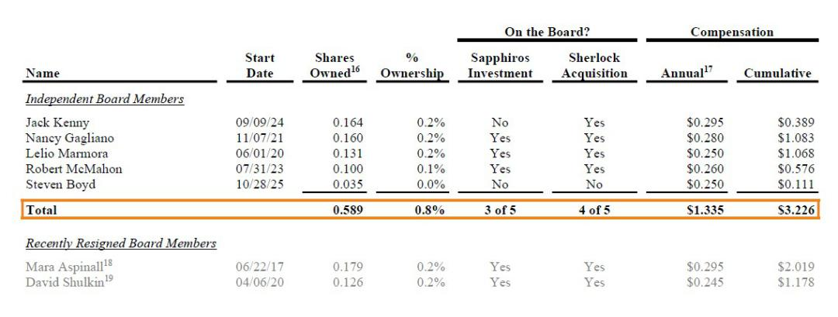

____________________________

- Source: Bloomberg, based on latest filing data.

- Estimated annual compensation is based on current Board roles and Board committee participation and compensation data provided in OraSure’s 2025 Proxy Statement.

- Resigned on 10/28/25. Annual compensation represents estimated 2025 compensation had Ms. Aspinall remained on Board for entirety of year.

- Resigned on 03/02/26. Annual compensation represents estimated 2025 compensation based on Mr. Shulkin's Board roles prior to resignation.

9

- Pay Without Performance

When the COVID windfall left OraSure with $3.94 per share of cash at the end of 2023, the Board entrusted Ms. Eglinton Manner to deploy that capital wisely. Over her nearly four-year tenure as CEO, she is estimated to have earned more than $15 million in total compensation, including unvested awards, while investors who held OraSure shares since the close of 2023 have lost 60% of their investment. This is not an abstract governance concern— it is a concrete transfer of wealth from shareholders to management enabled by a Board that has refused to hold its CEO accountable.

CEO Carrie Eglinton Manner’s Compensation20
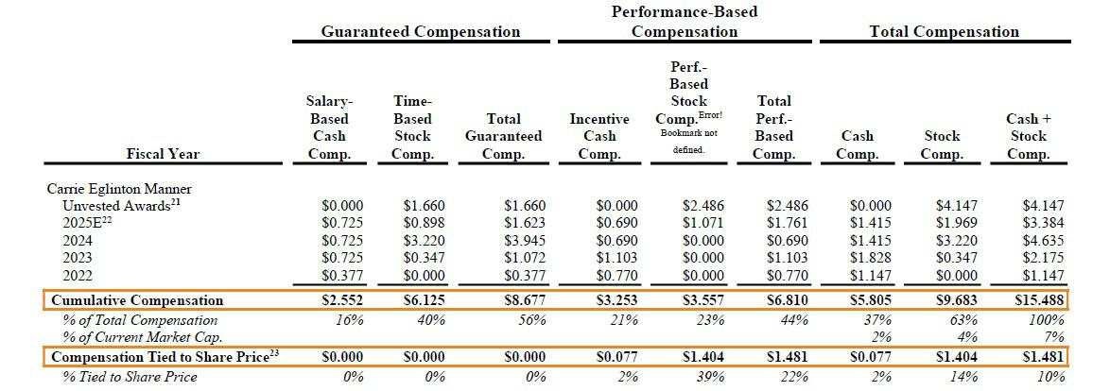

Ms. Eglinton Manner is incentivized to resist a sale: although a sale would deliver immediate value to shareholders, it would also end her roughly $4 million in annual compensation—most of which is guaranteed—representing 2% of OraSure’s market capitalization each year. The CEO’s economic interests are not aligned to the interests of the shareholders she serves.

The structure of this compensation is the wrong design for a company in OraSure’s position. Only 10% of Ms. Eglinton Manner’s cumulative compensation is linked to share price. The remaining 90% is paid through salary, time-based equity, and incentive bonuses tied to operating metrics— metrics that can, and did, pay out even as the stock declined 60%. Operating targets are inputs; share price is the outcome.

For a stable, growing business, this structure may appear reasonable. OraSure is not that company. It is burning cash, operating at 30% manufacturing capacity, and trading barely above the value of its cash balance. The central question facing shareholders is whether current management’s strategy will create equity value or further erode what remains.

We believe boards should pay extraordinary compensation only when management achieves extraordinary results. When this Board chose to support Ms.

Eglinton Manner’s high-risk capital allocation strategy, it should have tethered the vast majority of her compensation directly to share price performance.

It should have put her pay at risk. It did not.

One of the most fundamental responsibilities of any board is to hold executives accountable for poor performance. A board that understood the gravity of OraSure’s situation would have structured compensation to ensure that management bears real economic consequences if its strategy fails. This Board did the opposite. A CEO should not be handsomely rewarded for pursuing two questionable transactions while failing to drive either revenue growth or profitability. Upon our election, we will ensure that executive compensation at OraSure is restructured to align with shareholder returns.

_________________________

- Stock compensation values based on 03/06/26 closing share price ($3.19 per share). Salary-based cash compensation includes employer-matching contributions into 401k profit sharing plan.

- Unvested Awards assumes 2025 restricted stock (RS) and performance-vested restricted units (PRU) awards granted are the same as 2024.

- 2025E compensation assumes salary and incentive cash compensation is equal to 2024 figures.

- Estimates 10% of 2022 incentive cash compensation payout and 0% of 2023-2025E incentive cash compensation payout was linked to share price. Estimates 15% of 2022 PRU award, which vested in 2025, and 50% of 2023-2025E awards, which are unvested, are linked to share price.

10

- The Imperative for a Strategic Review

The diagnostics sector is a difficult market: competition is intense, pricing pressure is constant, products are often subject to unstable funding sources, and distribution requires significant ongoing investment. Scale matters enormously—the larger you are, the more efficiently you operate. Several smaller diagnostics companies similar in size to OraSure are valued at little to nothing by the market, in some cases below the value of their cash alone. If OraSure cannot grow revenue to a level that supports profitability, a meaningful recovery in its share price will be extremely difficult to achieve.

Comparable Company Analysis
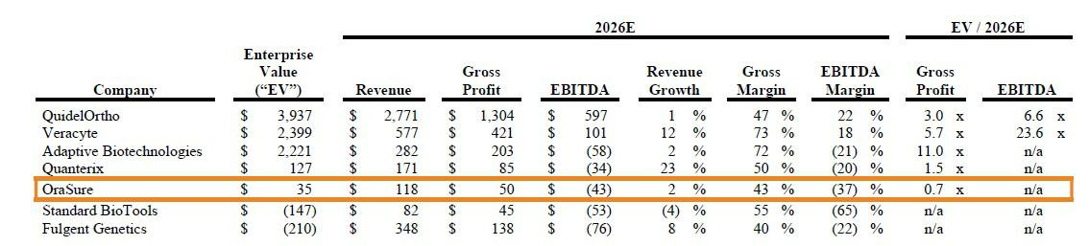

Against this backdrop, OraSure faces three realistic paths: (i) grow revenue through organic investment and better use of its capacity, (ii) acquire established businesses at fair prices that bring additional volume, enabling the Company to rationalize costs and reach profitability, or (iii) sell the business to a larger acquirer that can provide the scale and distribution OraSure needs. Given the Company’s track record with options (i) and (ii), we believe option (iii) deserves serious and immediate evaluation.

We believe OraSure is worth significantly more in a sale than as a standalone company. We value each component separately: the cash on its balance sheet, the current operating business, and the potential value of recent investments and acquisitions. At present, much of the value in OraSure’s share price simply reflects its cash balance. We believe the remaining operating business, including its underutilized manufacturing facility, could be worth between $145 million and $241 million to a strategic buyer. After deducting transaction costs (and valuing OraSure’s recent investments at cost in our “High” case), we estimate OraSure is worth $4.54 to $6.60 per share if sold—a 42% to 107% premium to today’s price. Through a competitive bidding process, especially if a buyer can underwrite significant synergies, these values could prove conservative.

Sum-of-the-Parts Valuation
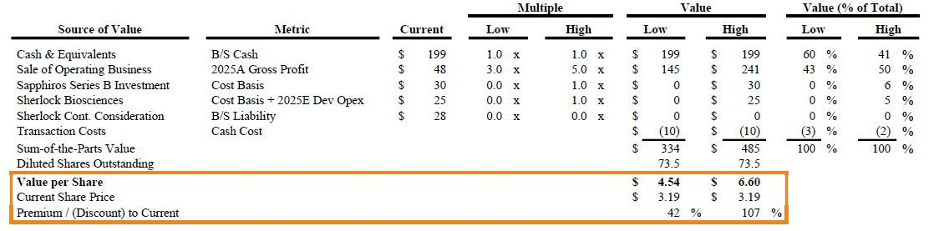

As newly elected Board members, John Bertrand and I will seek to initiate a full strategic review that weighs the immediate value of an outright sale against the opportunities and risks in the Company’s current plan. A key concern is that the Board and management have an inherent incentive to preserve the status quo: they continue receiving generous compensation regardless of whether the share price falls, while shareholders bear the risk of further losses. Shareholders may prefer an immediate return of value without the threat of further capital impairment. That option deserves a fair evaluation, and we intend to ensure it receives one.

11

- Nominees with a Track Record of Results

The best predictor of how a board member will serve shareholders is how they have served shareholders before.

In November 2023, I joined the board of ContextLogic which at the time was burning over $80 million of cash per quarter. After my appointment, ContextLogic sold its operating assets to Qoo10, a transaction that received overwhelming shareholder approval, and I was named ContextLogic’s CEO shortly thereafter in April 2024. As CEO, I significantly reduced the remaining expenses in the business, cutting cash burn to an insignificant amount.

In February 2025, I secured a $150 million strategic investment into ContextLogic from BC Partners, a well-known and highly-regarded investment firm founded in 1986 with over $40 billion of assets under management. Together, my colleagues at BC Partners and I, along with our excellent management team and board of directors, spent the next nine months continuing ContextLogic’s search for an acquisition target. On December 8, 2025, ContextLogic announced its acquisition of US Salt for $907.5 million, a transaction backstopped in part by newly committed capital from BC Partners, and I stepped down from my position as CEO. Following the announcement, ContextLogic’s shares closed at $8.10 per share, up over 120% from the low of $3.67 per share where its stock traded prior to my joining its board.²⁴

Throughout my time as CEO, my compensation was (and is) directly tied to share price. The performance unit grants I will receive, which constitute the vast majority of my remuneration, require that ContextLogic’s share price reaches $10.00, $16.00, $21.00, and $30.00 per share over the next four years. My compensation package reflects our adherence to the bedrock principle of aligning management incentives with shareholder value creation. We believe this is the same model that OraSure’s Board should apply.

BC Partners has stated both publicly, and in private conversations with OraSure’s Board, that they are eager to work with me again—a testament to the results we achieved together. My fellow nominee, John Bertrand, is an extremely well-respected executive with a deeply relevant background in the diagnostics sector. Together, we offer OraSure’s shareholders something they do not currently have: Board members whose economic interests are genuinely aligned with their own.

Conclusion

After endeavoring to work constructively with OraSure—including numerous conversations with Board members and management over several months —the Board refused to appoint us. Our decision to formally nominate was a last resort, but one we welcome. We would have preferred collaboration; instead, we will make our case directly to the investors who own this Company.

Since Altai Capital announced our formal director nominations in January 2026, OraSure’s share price has increased 18%. Even taking into account OraSure’s recent commentary around Sherlock’s FDA application status, this appreciation should be surprising given the substantial operating losses reported in late February for their 2025 fourth quarter. We are not surprised. Investors are encouraged by the prospect of governance changes at OraSure. Many have reached out since our filing to express support for our pursuit of representation on OraSure’s Board and their enthusiasm for either a settlement or the opportunity to vote for our nominees at the Annual Meeting.

We urge the Company to listen to its shareholders and reach a fair settlement that results in the appointment of John Bertrand and me to the Board. If the Board chooses to proceed to a vote, we will continue to present our case to OraSure shareholders and seek to win our appointment through election at the Annual Meeting.

Sincerely,
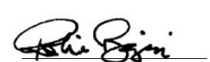

Rishi Bajaj

President & Chief Investment Officer

__________________________________________

- ContextLogic common stock closed at $3.67 per share on October 27, 2023, approximately one month before my appointment to its board on November 29, 2023. The US Salt acquisition was announced on Monday, December 8, 2025 and ContextLogic common stock closed at $8.10 per share by that Friday, December 12, 2025.

12

EXHIBIT A

Rishi Bajaj Biography:

Rishi Bajaj founded Altai Capital Management, L.P., a private investment firm, in 2009. He serves as its President and Chief Investment Officer, where he is responsible for the management and operations of the business. From 2024 to 2025, Mr. Bajaj also served as the Chief Executive Officer of ContextLogic Holdings Inc. (“ContextLogic”, OTCQB: LOGC).

Prior to founding Altai Capital, Mr. Bajaj served as a Senior Investment Analyst at Silver Point Capital, L.P., a private investment management firm, from 2003 to 2009, and as an M&A and Restructuring Analyst at Gleacher Partners, LLC, an M&A advisory firm, from 2001 to 2003.

Mr. Bajaj has served on the Board of Directors of Digimarc Corporation (“Digimarc”, NASDAQ: DMRC), a digital watermarking company, since July 2025. He is currently a member of Digimarc’s Audit Committee. Mr. Bajaj previously served (i) on the Board of Directors of ContextLogic from 2023 to 2025, where he served as Chairman, from 2024 to 2025, as well as a member of the Compensation Committee and Transformation Committee, (ii) on the Board of Directors of MobileIron, Inc. (NASDAQ: MOBL, formerly), a cybersecurity company, in 2020, where he served on the Strategy Committee, and (iii) on the Board of Directors of ServiceSource International, Inc. (NASDAQ: SREV, formerly), a software and services company, from 2014 to 2016, where he served on the Compensation Committee.

Mr. Bajaj holds a B.S. in Economics with concentrations in Finance and Statistics from The Wharton School at the University of Pennsylvania.

Mr. Bajaj’s qualifications to serve as a director of the Corporation include his years of service on public company boards and his extensive investment management experience and operational expertise, particularly in the technology sector.

13

EXHIBIT B

John Bertrand Biography:

John Bertrand co-founded and served as the Chief Executive Officer of Digital Diagnostics Inc., a leading health technology company, from 2019 to December 2025. In his role as CEO, Mr. Bertrand led the company’s transformation from a primarily research-driven organization to a commercial enterprise that acts as a global artificial intelligence platform to diagnose many diseases.

Previously, from 2006 to 2019, Mr. Bertrand served in various roles, including as a Business Development and Product Management Executive, at Epic Systems Corporation, a healthcare software company, where he led cross-functional teams in a variety of product, customer success, and business development roles with a focus on growth.

Mr. Bertrand has served in advisory roles and on the boards of directors of numerous technology companies. Mr. Bertrand has served as a Senior Advisor to Bain Capital, a private investment firm, since 2023, supporting the firm’s private equity practice in the healthcare information technology, diagnostics and therapeutics sectors. Mr. Bertrand has served in various roles, including as a Senior Advisor and Executive in Residence, at 8VC, a leading Silicon Valley venture capital firm focused on healthcare technology, since 2018. Mr. Bertrand has served on the Board of Directors of Keycare, Inc., a telehealth platform, since 2022, on the Board of Directors of Surlogs Inc., a regulatory compliance software company, since 2020, on the Board of Directors of Digital Diagnostics Inc., since 2019, and on the Board of Directors of Sirona Medical Inc., a medical software company, since 2019. Previously, Mr. Bertrand served on the Board of Advisors at Innovaccer, Inc., a digital healthcare company, from 2019 to 2020, and on the Board of Advisors at iRhythm Technologies Inc., a digital healthcare company, from 2019 to 2020. From 2018 to 2020, Mr. Bertrand served on the Board of Advisors of Digital Surgery, a health technology company, and from 2016 to 2018, he served on the Board of Advisors at Matrix Capital Management, a hedge fund.

Mr. Bertrand holds a B.S. in Business Management from Purdue University.

Mr. Bertrand’s qualifications to serve as a director of the Corporation include over a decade of executive leadership experience in the healthcare technology sector, where he has developed expertise in the application of artificial intelligence and computer vision in healthcare, identifying market opportunities, creating new products, and pivoting existing businesses.

14

About Altai Capital Management

Altai Capital Management (referred to herein as “Altai”, “Altai Capital” or “we”) is a technology-focused investment firm founded in 2009 by Rishi Bajaj. Altai makes long-term investments across a diverse range of financial instruments, including debt, private equity, venture capital, and publicly traded securities. To learn more, visit www.altai.com.

Disclaimers

This letter and the opinions herein are for general information only, and are not intended to be, nor should they be construed as, an offer to sell or a solicitation of an offer to buy any security, a recommendation to purchase or sell any security, or legal, financial, tax, investment, or other advice.

Select figures presented in this letter have not been calculated using generally accepted accounting principles (“GAAP”) and have not been audited by independent accountants. Such figures may vary from GAAP accounting in material respects and there can be no assurance that the unrealized values reflected within such materials will be realized. Nothing in this letter is intended to be a prediction of the future trading price or market value of securities of the Company. When used herein, the words “anticipate”, “believe”, “could”, “estimate”, “expect”, “may”, “ought to”, “plan”, “project”, “seek”, “should”, “will”, “would” and similar expressions, as they relate to OraSure Technologies, Inc. (referred to herein “OraSure”, “OraSure Technologies” or the “Company”), are intended to identify forward-looking statements. Reliance on any forward-looking statements involves known and unknown risks and uncertainties and there is no assurance or guarantee that actual results or performance of OraSure will not differ, and such differences may be material. In addition, there can be no assurance or guarantee with respect to the prices at which any securities of OraSure will trade, and such securities may not trade at prices that may be implied herein. The estimates, projections and potential impact of the opportunities identified by Altai Capital herein are based on assumptions that Altai Capital believes to be reasonable as of the date of this letter.

Altai Capital Management, L.P., Altai Capital Management, LLC, Altai Capital Osprey, LLC, Rishi Bajaj and John Bertrand (collectively, the “Participants”) intend to file with the SEC a definitive proxy statement and accompanying form of proxy to be used in connection with the solicitation of proxies from the stockholders of OraSure Technologies, Inc. Stockholders are advised to read the definitive proxy statement and other documents related to the solicitation of proxies by the Participants when they become available, as they will contain important information, including additional information related to the Participants. The definitive proxy statement and an accompanying proxy card will be furnished to OraSure Technologies, Inc. stockholders and will be, along with other relevant documents, available at no charge on the SEC website at http://www.sec.gov/.

Information about the Participants and a description of their direct or indirect interests, by security holdings or otherwise, is contained in Exhibit 1 to the Schedule 14A filed by the Participants with the SEC on March 17, 2026. This document is available free of charge from the source indicated above.

Exhibit 1

CERTAIN INFORMATION REGARDING THE PARTICIPANTS

The Participants (as defined below) intend to file a definitive proxy statement and accompanying form of proxy card with the Securities and Exchange Commission (the “SEC”) to be used in connection with the 2026 annual meeting of stockholders of OraSure Technologies, Inc. (the “Company”).

The “Participants” in this proxy solicitation are currently: (i) Altai Capital Management, L.P. (“Altai Investment Manager”), (ii) Altai Capital Management, LLC (“IMGP”), (iii) Altai Capital Osprey, LLC (“Osprey”), (iv) Rishi Bajaj (“Mr. Bajaj”) and (v) John Bertrand (“Mr. Bertrand”).

As of the date hereof, the Participants may be deemed to beneficially own (within the meaning of Rule 13d-3 under the Securities Exchange Act of 1934, as amended), in the aggregate, 3,613,836 shares of common stock, par value $0.000001 per share, of the Company (the “Common Stock”) (including the 100 shares of Common Stock held in record name by Osprey). Of the 3,613,836 shares of Common Stock (including the 100 shares of Common Stock held in record name by Osprey) beneficially owned in the aggregate by the Participants (i) 100 shares of Common Stock are directly owned in record name by Osprey and (ii) 3,613,736 shares of Common Stock are held in certain managed accounts (the “Managed Accounts”). By virtue of being the investment manager of Osprey and the Managed Accounts, Altai Investment Manager may be deemed to beneficially own 3,613,836 shares of Common Stock (including the 100 shares of Common Stock held in record name by Osprey). By virtue of being the general partner of Altai Investment Manager, IMGP may be deemed to beneficially own 3,613,836 shares of Common Stock (including the 100 shares of Common Stock held in record name by Osprey). By virtue of being the President and Chief Investment Officer of Altai Investment Manager, Mr. Bajaj may be deemed to beneficially own 3,613,836 shares of Common Stock (including the 100 shares of Common Stock held in record name by Osprey). Mr. Bertrand does not own any shares of Common Stock.

